

**Võ Viết Mạnh**

**HE163963**

**IA1604**

**Student Grading Manage**

1. **Phân tích và tổng hợp**

* Bảng điểm thành phần (DBI202)

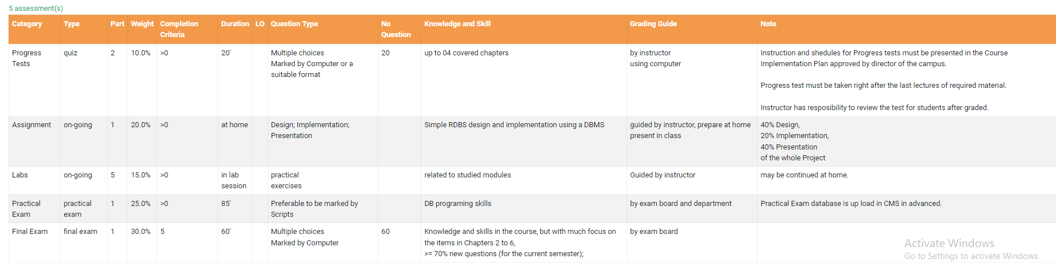

* Category: các loại hạng mục đánh giá: Progress Tests, Assignment, Labs, Practical Exam, Final Exam
* Type: cách đánh giá: Quiz, On-going, Practical exam, Final exam
* Part: số lần thực hiện: Ví dụ bài Quiz được thực hiện 2 lần
* Weight: trọng số (phần trăm) số điểm của từng hạng mục
* Completion Criteria: điểm tối thiểu cần đạt để qua môn
* Duration: thời gian thực hiện các hạng mục đánh giá : at home, in lab session, ...
* Question type: hình thức thực hiện: Multiple choices, Design, Implementation, Presentation, Practical exercises, Preferable to be marked by Scripts
* No question: số lượng câu hỏi
* Knowledge and Skill : các kiến thức và kĩ năng cần nắm vững
* Grading Guide: người chấm điểm và đánh giá: instructor using computer, exam board, ...
* Note: chú thích
* Bảng điểm tổng quát của sinh viên

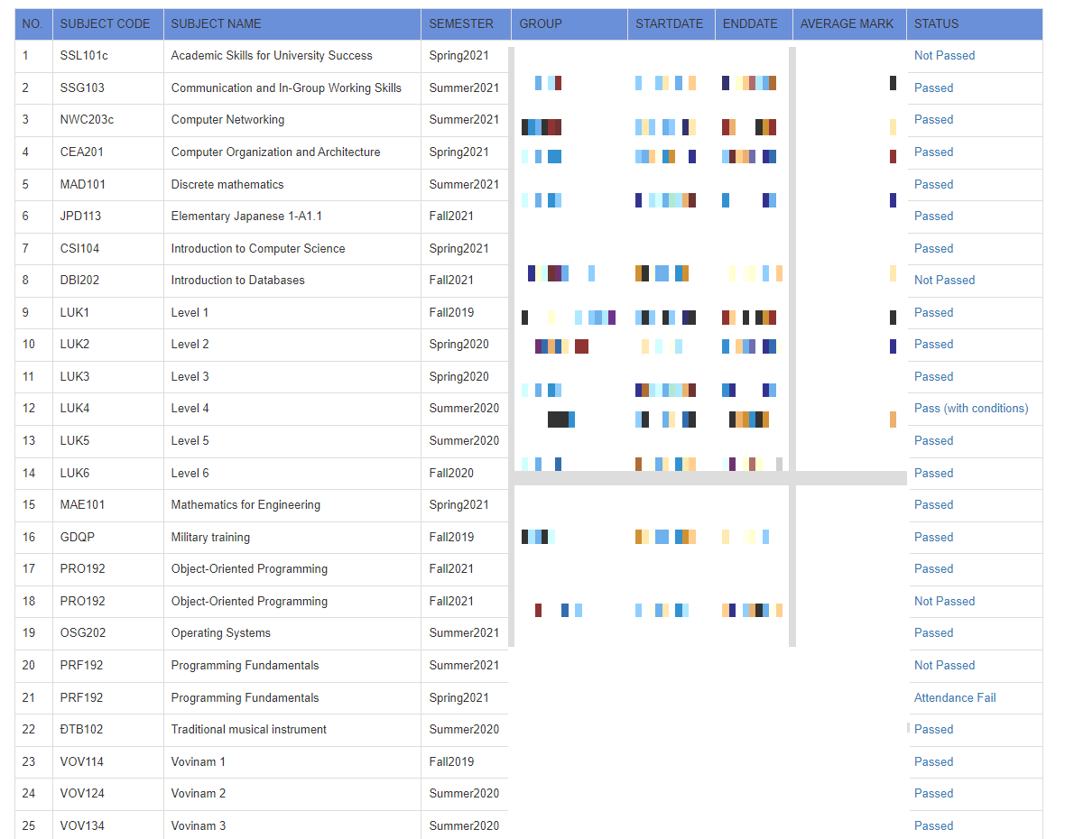

* No: số thứ tự các khóa học
* Subject code: mã khóa học
* Subject name: tên khóa học
* Semester: khóa học diễn ra vào kì + năm
* Group: lớp học
* Start date: thời gian bắt đầu khóa học
* End date: thời gian kết thúc khóa học
* Average mark: điểm trung bình
* Status: tổng kết quá trình học của sinh viên: Pass – Not pass
* Bảng điểm chi tiết 1 khóa học của sinh viên

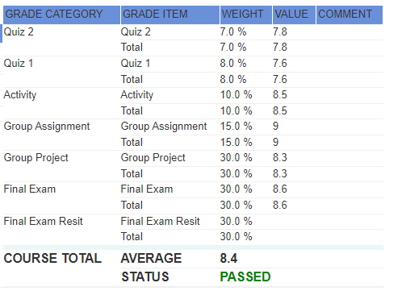

* Grade category: các loại hạng mục của từng đầu điểm
* Grade item: các thành phần của hạng mục (tên và đầu điểm), thêm 1 dòng total
* Weight: trọng số (phần trăm) số điểm của từng hạng mục
* Value: điểm
* Comment: chú thích của người quản lí điểm
* Course total: Điểm tổng kết của khóa và Status

1. **Xác định các Entities**

**Entity 1: Students**

* StudentID
* FirstName
* LastName
* Gender
* DoB
* Email

**Entity 2: Groups**

* GroupID
* Majors
* Number of Student

**Entity 3: Classes**

* ClassID
* AssignID
* Semester
* Start Date
* End Date

**Entity 4: Lectures**

* LectureID
* FirstName
* LastName
* DoB
* Email
* Gender
* Report

**Entity 5: Assignment**

* AssignmentID
* LecID
* Major

**Entity: Courses**

* CourseID
* AssignID
* CourseName

**Entity: Assessment System**

* AssessmentID
* CategoryID
* CourseID
* Duration
* Weight
* Number of questions

**Entity 8: Categories**

* CategoryID
* CategoryName
* Type
* Completion Criteria

1. **ERD Diagram**

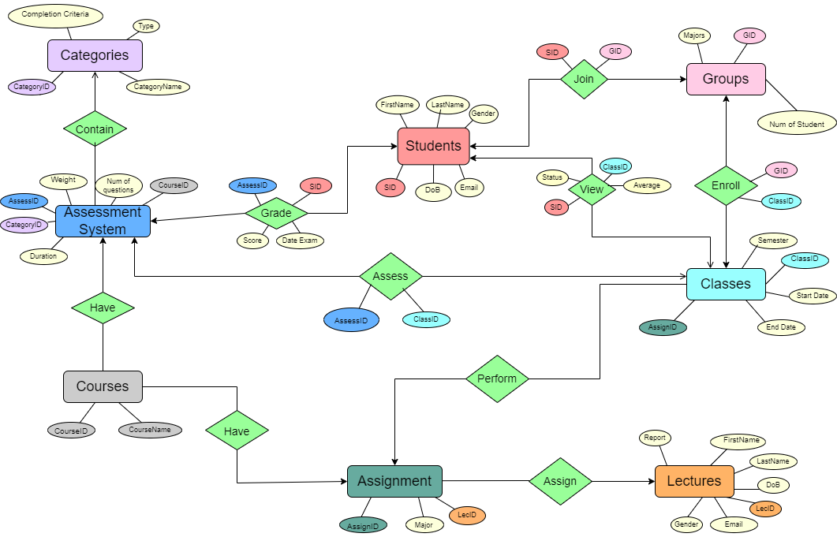

1. **Phân tích mối quan hệ giữa các Entities**

* **Entity Students <-> Entity Groups**

Một sinh viên có thể tham gia nhiều nhóm lớp học và một nhóm lớp học cũng có thể có nhiều sinh viên

* Mối quan hệ: N-N
* **Entity Groups <-> Entity Classes**

Một nhóm có thể đăng kí nhiều lớp học và một lớp học có thể chứa nhiều nhóm

* Mối quan hệ: N-N
* **Entity Lectures <-> Entity Assignment**

Một giảng viên chỉ có thể ra đúng một Assignment và một Assignment có thể được nhiều giảng viên ra

* Mối quan hệ: 1-N
* **Entity Assignment <-> Entity Courses**

Một Assignment có thể lấy từ nhiều Coures và một Course chỉ có thể có một Assignment

* Mối quan hệ: 1-N
* **Entity Assignment <-> Entity Classes**

Một lớp chỉ có một Assignment và một Assignment có thể được giao cho nhiều lớp

* Mối quan hệ: 1-N
* **Entity Students <-> Entity Classes**

Một sinh viên có thể xem được điểm của nhiều lớp và một lớp có thể có nhiều đầu điểm của sinh viên

* Mối qua hệ: N-N
* **Entity Courses <-> Entity Assessment System**

Một Courses chỉ có một hệ thống đánh giá và một Assessment System có thể là hệ thống đánh giá của nhiều Courses

* Mối quan hệ: 1-N
* **Entity Assessment System <-> Entity Categories**

Một Category có thể tổng hợp từ nhiều hệ thống đánh giá và một hệ thống đánh giá chỉ có thể đưa vào một Categoty

* Mối quan hệ: 1-N
* **Entity Assessmeny System <-> Entity Students**

Một sinh viên có thế có nhiều hệ thống đánh giá các đầu điểm và một hệ thống đánh giá cũng có thể phụ trách đầu điểm của nhiều sinh viên

* Mối quan hệ: N-N
* **Entity Assessment System <-> Entity Classes**

Một lớp học có thể có nhiều hệ thống đánh giá và một hệ thống đánh giá có thể phụ trách đầu điểm của nhiều lớp

* Mối quan hệ: N-N

1. **Phân tách các quan hệ N-N giữa các Entity và tạo bảng**

* Students và Groups -> Tạo Table Join (SID, GID)
* Table_Students <-> Table_Join (SID, GID) <-> Table_ Groups
* Groups và Classes -> Tạo Table Enroll (GID, ClassID)
* Table_Groups <-> Table_Enroll (GID, ClassID) <-> Table_Classes
* Assessment System và Classes -> Tạo Table Assess (AssessID, ClassID)
* Table_Assessment_System <-> Table_Assess (AssessID, ClassID) <->Table_Classes
* Assessment System và Students -> Tạo bảng Grade (AssessID, SID)
* Table_Assessment_System <-> Table_Grade (AssessID, SID) <-> Table_Students
* Students và Classes -> Tạo Table View (SID, ClassID)
* Table_Students <-> Table_View (SID, ClassID) <-> Table_Classes

1. **Định dạng kiểu dữ liệu các Attributes trên từng Table**

* **Table Students**

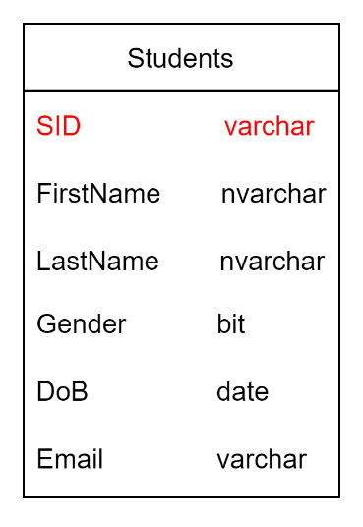

* **Table Join**

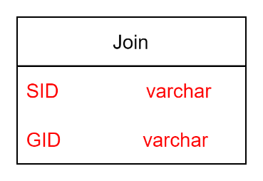

* **Table Groups**

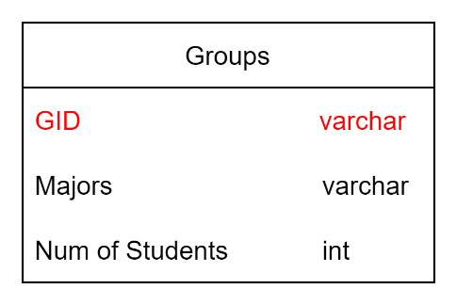

* **Table Enroll**

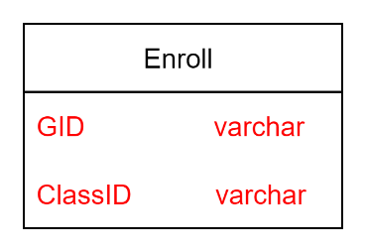

* **Table Classes**

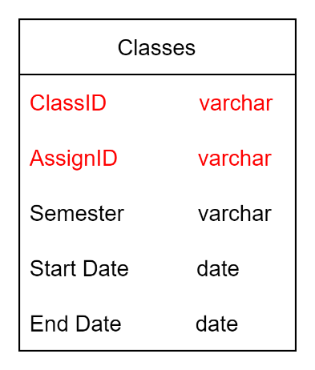

* **Table Lectures**

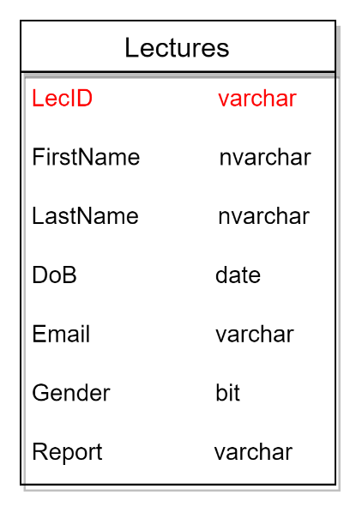

* **Table Assigment**

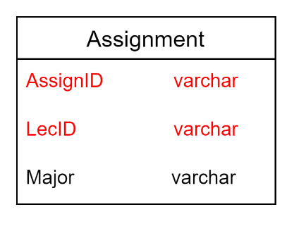

* **Table Courses**

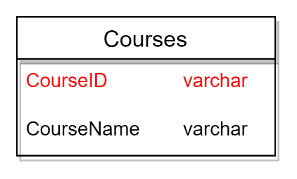

* **Table Assessment System**

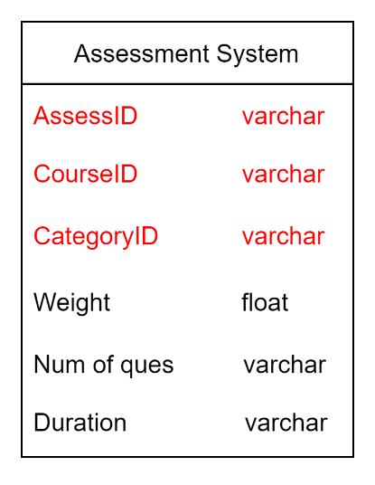

* **Table Categories**

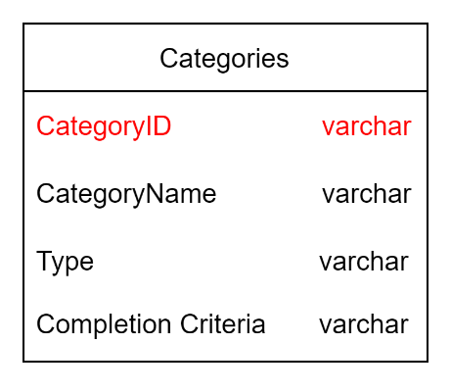

* **Table Grade**

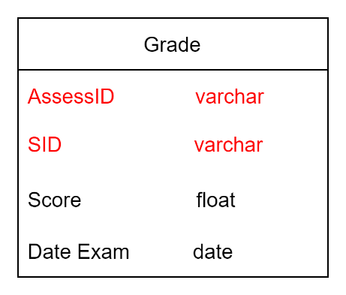

* **Table Assess**

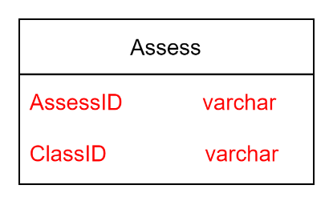

* **Table View**

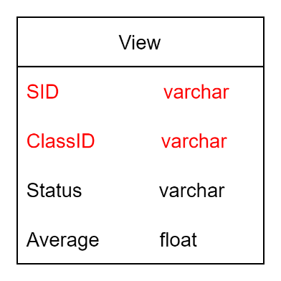

1. **Database Diagram**

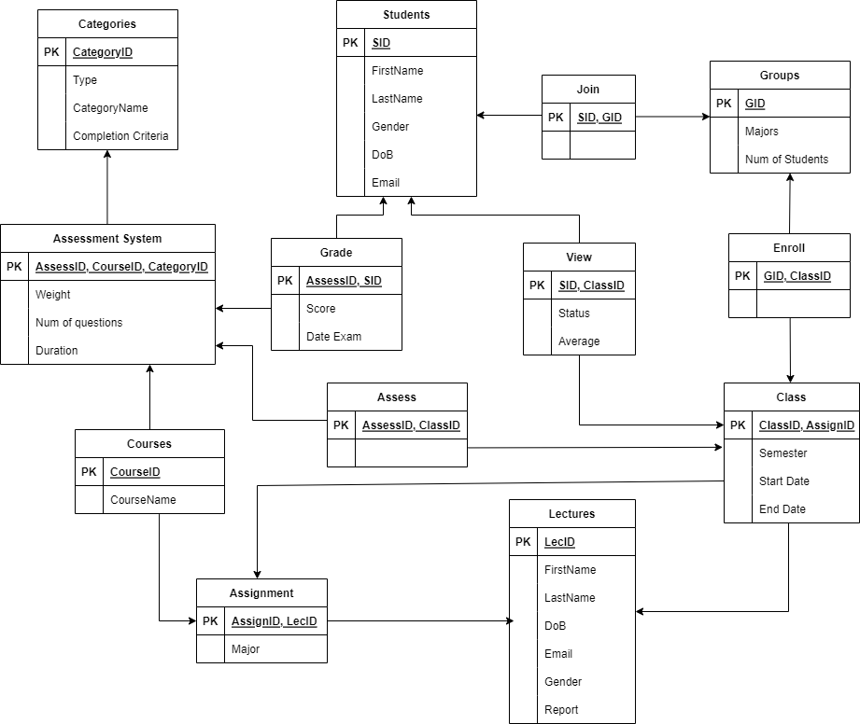

1. **Xác định Primary Key, Foreign Key, Attributes các Tables.**

* **Table Students**

|  |  |  |  |  |
| --- | --- | --- | --- | --- |
| **Attributes** | **Type** | **Format** | **Requires** | **Key** |
| SID | Varchar | 35 | Not Null | Primary Key |
| FirstName | Nvarchar | 35 | Not Null |  |
| LastName | Nvarchar | 35 | Not Null |  |
| Gender | Bit |  | Not Null |  |
| DoB | Date | yyyy/mm/dd | Not Null |  |
| Email | Varchar | 50 | Not Null |  |

* **Table Join**

|  |  |  |  |  |
| --- | --- | --- | --- | --- |
| **Attributes** | **Type** | **Format** | **Requires** | **Key** |
| SID | Varchar | 35 | Not Null | Primary_Foreign Key |
| GID | Varchar | 35 | Not Null | Primary_Foreign Key |

* **Table Groups**

|  |  |  |  |  |
| --- | --- | --- | --- | --- |
| **Attributes** | **Type** | **Format** | **Requires** | **Key** |
| GID | Varchar | 35 | Not Null | Primary Key |
| Major | Varchar | 35 | Not Null |  |
| Num of Students | Int |  | Not Null |  |

* **Table Enroll**

|  |  |  |  |  |
| --- | --- | --- | --- | --- |
| **Attributes** | **Type** | **Format** | **Requires** | **Key** |
| GID | Varchar | 35 | Not Null | Primary_Foreign Key |
| ClassID | Varchar | 35 | Not Null | Primary_Foreign Key |

* **Table Classes**

|  |  |  |  |  |
| --- | --- | --- | --- | --- |
| **Attributes** | **Type** | **Format** | **Requires** | **Key** |
| ClassID | Varchar | 35 | Not Null | Primary Key |
| AssignID | Varchar | 35 | Not Null | Foreign Key |
| Semester | Varchar | 35 | Not Null |  |
| Start Date | date | yyyy/mm/dd | Not Null |  |
| End Date | date | yyyy/mm/dd | Not Null |  |

* **Table Lectures**

|  |  |  |  |  |
| --- | --- | --- | --- | --- |
| **Attributes** | **Type** | **Format** | **Requires** | **Key** |
| LecID | Varchar | 35 | Not Null | Primary Key |
| FirstName | Nvarchar | 35 | Not Null |  |
| LastName | Nvarchar | 35 | Not Null |  |
| DoB | Date | yyyy/mm/dd | Not Null |  |
| Email | Varchar | 50 | Not Null |  |
| Gender | Bit |  | Not Null |  |
| Report | Varchar | 35 | Null | Foreign Key |

* **Table Assignment**

|  |  |  |  |  |
| --- | --- | --- | --- | --- |
| **Attributes** | **Type** | **Format** | **Requires** | **Key** |
| AssignID | Varchar | 35 | Not Null | Primary Key |
| LecID | Varchar | 35 | Not Null | Foreign Key |
| Major | Varchar | 35 | Not Null |  |

* **Table Courses**

|  |  |  |  |  |
| --- | --- | --- | --- | --- |
| **Attributes** | **Type** | **Format** | **Requires** | **Key** |
| CourseID | Varchar | 35 | Not Null | Primary Key |
| CourseName | Varchar | 35 | Not Null |  |

* **Table Assessment System**

|  |  |  |  |  |
| --- | --- | --- | --- | --- |
| **Attributes** | **Type** | **Format** | **Requires** | **Key** |
| AssessID | Varchar | 35 | Not Null | Primary Key |
| CourseID | Varchar | 35 | Not Null | Foreign Key |
| CategoryID | Varchar | 35 | Not Null | Foreign Key |
| Weight | Float | 35 | Not Null |  |
| Num of Ques | Varchar | 35 | Not Null |  |
| Email | Varchar | 50 | Not Null |  |

* **Table Categories**

|  |  |  |  |  |
| --- | --- | --- | --- | --- |
| **Attributes** | **Type** | **Format** | **Requires** | **Key** |
| CategoryID | Varchar | 35 | Not Null | Primary Key |
| Type | Varchar | 35 | Not Null |  |
| CategoryName | Varchar | 35 | Not Null |  |
| Completion Criteria | Varchar | 35 | Not Null |  |

* **Table Grade**

|  |  |  |  |  |
| --- | --- | --- | --- | --- |
| **Attributes** | **Type** | **Format** | **Requires** | **Key** |
| SID | Varchar | 35 | Not Null | Primary_Foreign Key |
| AssessID | Varchar | 35 | Not Null | Primary_Foreign Key |
| Score | Float | 35 | Not Null |  |
| Date Exam | Date | yyyy/mm/dd | Not Null |  |

* **Table Assess**

|  |  |  |  |  |
| --- | --- | --- | --- | --- |
| **Attributes** | **Type** | **Format** | **Requires** | **Key** |
| AssessID | Varchar | 35 | Not Null | Primary_Foreign Key |
| ClassID | Varchar | 35 | Not Null | Primary_Foreign Key |

* **Table View**

|  |  |  |  |  |
| --- | --- | --- | --- | --- |
| **Attributes** | **Type** | **Format** | **Requires** | **Key** |
| SID | Varchar | 35 | Not Null | Primary_Foreign Key |
| ClassID | Varchar | 35 | Not Null | Primary_Foreign Key |
| Status | Varchar | 35 | Not Null |  |
| Average | Float | 35 | Not Null |  |

1. **Tạo Database Diagram và đưa dữ liệu vào**

* **Create Tables and Attributes**

CREATE TABLE Students (

[SID] [varchar](35) NOT NULL PRIMARY KEY,

[Email] [varchar](50) NOT NULL,

[First Name] [nvarchar](35) NOT NULL,

[Last Name] [nvarchar](35) NOT NULL,

[Gender] [bit] NOT NULL,

[Date of Birth] [date] NOT NULL,

)

CREATE TABLE Groups (

[GID] [varchar](35) NOT NULL PRIMARY KEY,

[Major] [varchar](35) NOT NULL,

[Num of Students] [int] NOT NULL,

)

CREATE TABLE [Join] (

[SID] [varchar](35) NOT NULL,

[GID] [varchar](35) NOT NULL,

CONSTRAINT [PK_Join] PRIMARY KEY (SID, GID),

CONSTRAINT [FK_Join_Groups] FOREIGN KEY([GID]) REFERENCES [dbo].[Groups] ([GID]),

CONSTRAINT [FK_Join_Students] FOREIGN KEY([SID]) REFERENCES [dbo].[Students] ([SID])

)

CREATE TABLE Lectures (

[LecID] [varchar](35) NOT NULL PRIMARY KEY,

[Email] [varchar](50) NOT NULL,

[First Name] [nvarchar](35) NOT NULL,

[Last Name] [nvarchar](35) NOT NULL,

[Gender] [bit] NOT NULL,

[Date of Birth] [date] NOT NULL,

[Report] [varchar](35) NULL,

CONSTRAINT [FK_Lectures_Lectures] FOREIGN KEY([Report]) REFERENCES [dbo].[Lectures] ([LecID]),

)

CREATE TABLE Courses (

[CourseID] [varchar](35) NOT NULL PRIMARY KEY,

[CourseName] [varchar](35) NOT NULL,

)

CREATE TABLE Assignment (

[AssignID] [varchar](35) NOT NULL PRIMARY KEY,

[Major] [varchar](35) NOT NULL,

[Lecture] [varchar](35) NOT NULL,

CONSTRAINT [FK_Assignment_Courses] FOREIGN KEY([Major]) REFERENCES [dbo].[Courses] ([CourseID]),

CONSTRAINT [FK_Assignment_Lectures] FOREIGN KEY([Lecture]) REFERENCES [dbo].[Lectures] ([LecID]),

)

CREATE TABLE Classes (

[ClassID] [varchar](35) NOT NULL PRIMARY KEY,

[AssignID] [varchar](35) NOT NULL,

[Semester] [varchar](35) NOT NULL,

[Start Date] [date] NOT NULL,

[End Date] [date] NOT NULL,

CONSTRAINT [FK_Classes_Assignment] FOREIGN KEY([AssignID]) REFERENCES [dbo].[Assignment] ([AssignID]),

)

CREATE TABLE Enroll (

[ClassID] [varchar](35) NOT NULL,

[GID] [varchar](35) NOT NULL,

CONSTRAINT [PK_Enroll] PRIMARY KEY (ClassID, GID),

CONSTRAINT [FK_Enroll_Classes] FOREIGN KEY([ClassID]) REFERENCES [dbo].[Classes] ([ClassID]),

CONSTRAINT [FK_Enroll_Groups] FOREIGN KEY([GID]) REFERENCES [dbo].[Groups] ([GID])

)

CREATE TABLE Categories (

[CategoryID] [varchar](35) NOT NULL PRIMARY KEY ,

[CategoryName] [varchar](35) NOT NULL,

[Type] [varchar](35) NOT NULL,

[Completion Criteria] [varchar](35) NOT NULL,

)

CREATE TABLE [Assessment System] (

[AssessID] [varchar](35) NOT NULL PRIMARY KEY,

[CategoryID] [varchar](35) NOT NULL,

[CourseID] [varchar](35) NOT NULL,

[Num of Ques] [int] NOT NULL,

[Duration] [varchar](35) NOT NULL,

[Weight] [float] NOT NULL,

CONSTRAINT [FK_Assessment System_Categories] FOREIGN KEY([CategoryID]) REFERENCES [dbo].[Categories] ([CategoryID]),

CONSTRAINT [FK_Assessment System_Courses] FOREIGN KEY([CourseID]) REFERENCES [dbo].[Courses] ([CourseID]),

)

CREATE TABLE Assess (

[AssessID] [varchar](35) NOT NULL,

[ClassID] [varchar](35) NOT NULL,

CONSTRAINT [PK_Assess] PRIMARY KEY (AssessID, ClassID),

CONSTRAINT [FK_Assess_Assessment System] FOREIGN KEY([AssessID]) REFERENCES [dbo].[Assessment System] ([AssessID]),

CONSTRAINT [FK_Assess_Classes] FOREIGN KEY([ClassID]) REFERENCES [dbo].[Classes] ([ClassID]),

)

CREATE TABLE Grade (

[SID] [varchar](35) NOT NULL,

[AssessID] [varchar](35) NOT NULL,

[Score] [float] NOT NULL,

[Date] [date] NOT NULL,

CONSTRAINT [FK_Grade_Assessment System] FOREIGN KEY([AssessID]) REFERENCES [dbo].[Assessment System] ([AssessID]),

CONSTRAINT [FK_Grade_Students] FOREIGN KEY([SID]) REFERENCES [dbo].[Students] ([SID]),

CONSTRAINT [PK_Grade] PRIMARY KEY (SID, AssessID, [Date]),

)

CREATE TABLE [View] (

[SID] [varchar](35) NOT NULL,

[ClassID] [varchar](35) NOT NULL,

[Average] [float] NOT NULL,

[Status] [varchar](35) NOT NULL,

CONSTRAINT [PK_View] PRIMARY KEY (SID, ClassID),

CONSTRAINT [FK_View_Classes] FOREIGN KEY([ClassID]) REFERENCES [dbo].[Classes] ([ClassID]),

CONSTRAINT [FK_View_Students] FOREIGN KEY([SID]) REFERENCES [dbo].[Students] ([SID]),

)

* **Image result**

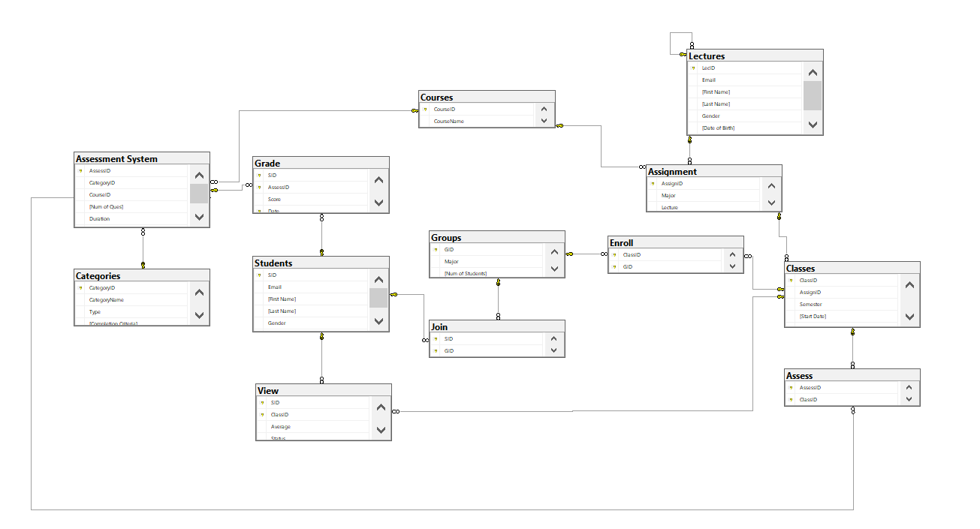

* **SELECT * FROM Students**

INSERT [dbo].[Students] ([SID], [Email], [First Name], [Last Name], [Gender], [Date of Birth]) VALUES (N'HE160001', N'chungdv@fpt.edu.vn', N'Chung', N'Đỗ Văn', 1, CAST(N'2002-07-05' AS Date));

INSERT [dbo].[Students] ([SID], [Email], [First Name], [Last Name], [Gender], [Date of Birth]) VALUES (N'HE160002', N'ducnvfpt.edu.vn', N'Đức', N'Nguyễn Văn', 1, CAST(N'2002-03-09' AS Date));

INSERT [dbo].[Students] ([SID], [Email], [First Name], [Last Name], [Gender], [Date of Birth]) VALUES (N'HE160003', N'anhlv@fpt.edu.vn', N'Anh', N'Lê Việt', 1, CAST(N'2002-06-10' AS Date));

INSERT [dbo].[Students] ([SID], [Email], [First Name], [Last Name], [Gender], [Date of Birth]) VALUES (N'HE160004', N'dathm@fpt.edu.vn', N'Đạt', N'Hà Mạnh', 1, CAST(N'2002-07-19' AS Date));

INSERT [dbo].[Students] ([SID], [Email], [First Name], [Last Name], [Gender], [Date of Birth]) VALUES (N'HE160005', N'namtv@fpt.edu.vn', N'Nam', N'Tạ Việt', 1, CAST(N'2002-09-17' AS Date));

INSERT [dbo].[Students] ([SID], [Email], [First Name], [Last Name], [Gender], [Date of Birth]) VALUES (N'HE160006', N'huyvd@fpt.edu.vn', N'Huy', N'Vũ Đức', 1, CAST(N'2002-09-01' AS Date));

INSERT [dbo].[Students] ([SID], [Email], [First Name], [Last Name], [Gender], [Date of Birth]) VALUES (N'HE160007', N'duccn@fpt.edu.vn', N'Đức', N'Châu Ngọc', 1, CAST(N'2002-10-11' AS Date));

INSERT [dbo].[Students] ([SID], [Email], [First Name], [Last Name], [Gender], [Date of Birth]) VALUES (N'HE160008', N'anhdd@fpt.edu.vn', N'Anh', N'Đỗ Đức', 1, CAST(N'2002-06-22' AS Date));

INSERT [dbo].[Students] ([SID], [Email], [First Name], [Last Name], [Gender], [Date of Birth]) VALUES (N'HE160009', N'huynn@fpt.edu.vn', N'Huy', N'Nguyễn Nhật', 1, CAST(N'2002-03-08' AS Date));

INSERT [dbo].[Students] ([SID], [Email], [First Name], [Last Name], [Gender], [Date of Birth]) VALUES (N'HE160010', N'dattcd@fpt.edu.vn', N'Đạt', N'Trần Công Doãn', 1, CAST(N'2002-10-20' AS Date));

INSERT [dbo].[Students] ([SID], [Email], [First Name], [Last Name], [Gender], [Date of Birth]) VALUES (N'HE160011', N'tamttt@fpt.edu.vn', N'Tâm', N'Trần Thị Thanh', 0, CAST(N'2002-01-21' AS Date));

INSERT [dbo].[Students] ([SID], [Email], [First Name], [Last Name], [Gender], [Date of Birth]) VALUES (N'HE160012', N'datnt@fpt.edu.vn', N'Đat', N'Nguyễn Thành', 1, CAST(N'2002-08-23' AS Date));

INSERT [dbo].[Students] ([SID], [Email], [First Name], [Last Name], [Gender], [Date of Birth]) VALUES (N'HE160013', N'hath@fpt.edu.vn', N'Hà', N'Trần Hải', 1, CAST(N'2002-07-03' AS Date));

INSERT [dbo].[Students] ([SID], [Email], [First Name], [Last Name], [Gender], [Date of Birth]) VALUES (N'HE160014', N'quandm@fpt.edu.vn', N'Quân', N'Đỗ Minh', 1, CAST(N'2002-10-12' AS Date));

INSERT [dbo].[Students] ([SID], [Email], [First Name], [Last Name], [Gender], [Date of Birth]) VALUES (N'HE160015', N'duongnn@fpt.edu.vn', N'Dương', N'Nguyễn Ngọc', 1, CAST(N'2002-07-31' AS Date));

INSERT [dbo].[Students] ([SID], [Email], [First Name], [Last Name], [Gender], [Date of Birth]) VALUES (N'HE160016', N'thinhnd@fpt.edu.vn', N'Thịnh', N'Nguyễn Doanh', 1, CAST(N'2002-08-08' AS Date));

INSERT [dbo].[Students] ([SID], [Email], [First Name], [Last Name], [Gender], [Date of Birth]) VALUES (N'HE160017', N'duongnt@fpt.edu.vn', N'Dương', N'Nguyễn Tùng', 1, CAST(N'2002-07-22' AS Date));

INSERT [dbo].[Students] ([SID], [Email], [First Name], [Last Name], [Gender], [Date of Birth]) VALUES (N'HE160018', N'anhvt@fpt.edu.vn', N'Anh', N'Vũ Tuấn', 1, CAST(N'2002-03-03' AS Date));

INSERT [dbo].[Students] ([SID], [Email], [First Name], [Last Name], [Gender], [Date of Birth]) VALUES (N'HE160019', N'thanhtd@fpt.edu.vn', N'Thành', N'Triệu Đức', 1, CAST(N'2002-05-15' AS Date));

INSERT [dbo].[Students] ([SID], [Email], [First Name], [Last Name], [Gender], [Date of Birth]) VALUES (N'HE160020', N'hieulkm@fpt.edu.vn', N'Hiếu', N'Lê Khắc Minh', 1, CAST(N'2002-04-04' AS Date));

INSERT [dbo].[Students] ([SID], [Email], [First Name], [Last Name], [Gender], [Date of Birth]) VALUES (N'HE160021', N'vuongnv@fpt.edu.vn', N'Vương', N'Nguyễn Văn', 1, CAST(N'2002-03-31' AS Date));

INSERT [dbo].[Students] ([SID], [Email], [First Name], [Last Name], [Gender], [Date of Birth]) VALUES (N'HE160022', N'minhtt@fpt.edu.vn', N'Minh', N'Trương Hoàng', 1, CAST(N'2002-02-08' AS Date));

INSERT [dbo].[Students] ([SID], [Email], [First Name], [Last Name], [Gender], [Date of Birth]) VALUES (N'HE160023', N'hiepdv@fpt.edu.vn', N'Hiệp', N'Đào Vũ', 1, CAST(N'2002-11-20' AS Date));

INSERT [dbo].[Students] ([SID], [Email], [First Name], [Last Name], [Gender], [Date of Birth]) VALUES (N'HE160024', N'thuongnc@fpt.edu.vn', N'Thương', N'Nguyễn Cảnh', 1, CAST(N'2002-02-15' AS Date));

INSERT [dbo].[Students] ([SID], [Email], [First Name], [Last Name], [Gender], [Date of Birth]) VALUES (N'HE160025', N'huynq@fpt.edu.vn', N'Huy', N'Nguyễn Quang', 1, CAST(N'2002-01-15' AS Date));

INSERT [dbo].[Students] ([SID], [Email], [First Name], [Last Name], [Gender], [Date of Birth]) VALUES (N'HE160026', N'namnn@fpt.edu.vn', N'Nam', N'Nguyễn Nhật', 1, CAST(N'2002-01-29' AS Date));

INSERT [dbo].[Students] ([SID], [Email], [First Name], [Last Name], [Gender], [Date of Birth]) VALUES (N'HE160027', N'quangnv@fpt.edu.vn', N'Quang', N'Nguyễn Văn', 1, CAST(N'2002-02-28' AS Date));

INSERT [dbo].[Students] ([SID], [Email], [First Name], [Last Name], [Gender], [Date of Birth]) VALUES (N'HE160028', N'sont@fpt.edu.vn', N'Sơn', N'Trịnh Tùng', 1, CAST(N'2002-02-01' AS Date));

INSERT [dbo].[Students] ([SID], [Email], [First Name], [Last Name], [Gender], [Date of Birth]) VALUES (N'HE160029', N'dangph@fpt.edu.vn', N'Đăng', N'Phạm Hồng', 1, CAST(N'2002-09-23' AS Date));

INSERT [dbo].[Students] ([SID], [Email], [First Name], [Last Name], [Gender], [Date of Birth]) VALUES (N'HE160030', N'manhvv@fpt.edu.vn', N'Mạnh', N'Võ Viết', 1, CAST(N'2002-07-26' AS Date));

INSERT [dbo].[Students] ([SID], [Email], [First Name], [Last Name], [Gender], [Date of Birth]) VALUES (N'HE160031', N'vutq@fpt.edu.vn', N'Vũ', N'Thái Quang', 1, CAST(N'2002-12-15' AS Date));

INSERT [dbo].[Students] ([SID], [Email], [First Name], [Last Name], [Gender], [Date of Birth]) VALUES (N'HE160032', N'vietpq@fpt.edu.vn', N'Việt', N'Phạm Quang', 1, CAST(N'2002-12-26' AS Date));

INSERT [dbo].[Students] ([SID], [Email], [First Name], [Last Name], [Gender], [Date of Birth]) VALUES (N'HE160033', N'dantt@fpt.edu.vn', N'Đan', N'Trần Thái', 1, CAST(N'2002-01-29' AS Date));

INSERT [dbo].[Students] ([SID], [Email], [First Name], [Last Name], [Gender], [Date of Birth]) VALUES (N'HE160034', N'uyennt@fpt.edu.vn', N'Uyên', N'Nguyễn Thu', 0, CAST(N'2002-04-16' AS Date));

INSERT [dbo].[Students] ([SID], [Email], [First Name], [Last Name], [Gender], [Date of Birth]) VALUES (N'HE160035', N'vanvt@fpt.edu.vn', N'Vân', N'Vũ Thảo', 0, CAST(N'2002-07-13' AS Date));

INSERT [dbo].[Students] ([SID], [Email], [First Name], [Last Name], [Gender], [Date of Birth]) VALUES (N'HE160036', N'linhpt@fpt.edu.vn', N'Linh', N'Phan Thùy', 0, CAST(N'2002-07-18' AS Date));

INSERT [dbo].[Students] ([SID], [Email], [First Name], [Last Name], [Gender], [Date of Birth]) VALUES (N'HE160037', N'tudt@fpt.edu.vn', N'Tú', N'Dương Trần', 1, CAST(N'2002-05-14' AS Date));

INSERT [dbo].[Students] ([SID], [Email], [First Name], [Last Name], [Gender], [Date of Birth]) VALUES (N'HE160038', N'quocnt@fpt.edu.vn', N'Quốc', N'Nguyễn Trung', 1, CAST(N'2002-11-11' AS Date));

INSERT [dbo].[Students] ([SID], [Email], [First Name], [Last Name], [Gender], [Date of Birth]) VALUES (N'HE160039', N'binhlb@fpt.edu.vn', N'Bình', N'Lê Bảo', 1, CAST(N'2002-09-12' AS Date));

INSERT [dbo].[Students] ([SID], [Email], [First Name], [Last Name], [Gender], [Date of Birth]) VALUES (N'HE160040', N'tungnt@fpt.edu.vn', N'Tùng', N'Nguyễn Thanh', 1, CAST(N'2002-02-10' AS Date));

INSERT [dbo].[Students] ([SID], [Email], [First Name], [Last Name], [Gender], [Date of Birth]) VALUES (N'HE160041', N'anhnn@fpt.edu.vn', N'Anh', N'Nguyễn Ngọc', 0, CAST(N'2002-07-13' AS Date));

INSERT [dbo].[Students] ([SID], [Email], [First Name], [Last Name], [Gender], [Date of Birth]) VALUES (N'HE160042', N'nguyetht@fpt.edu.vn', N'Nguyệt', N'Hoàng Thị', 0, CAST(N'2002-05-04' AS Date));

INSERT [dbo].[Students] ([SID], [Email], [First Name], [Last Name], [Gender], [Date of Birth]) VALUES (N'HE160043', N'tungtv@fpt.edu.vn', N'Tùng', N'Trần Văn', 1, CAST(N'2002-08-04' AS Date));

INSERT [dbo].[Students] ([SID], [Email], [First Name], [Last Name], [Gender], [Date of Birth]) VALUES (N'HE160044', N'hoangdv@fpt.edu.vn', N'Hoàng', N'Đào Văn', 1, CAST(N'2002-02-09' AS Date));

INSERT [dbo].[Students] ([SID], [Email], [First Name], [Last Name], [Gender], [Date of Birth]) VALUES (N'HE160045', N'daoha@fpt.edu.vn', N'Đào', N'Hà Anh', 0, CAST(N'2002-05-05' AS Date));

INSERT [dbo].[Students] ([SID], [Email], [First Name], [Last Name], [Gender], [Date of Birth]) VALUES (N'HE160046', N'trangnt@fpt.edu.vn', N'Trang', N'Nguyễn Thùy', 0, CAST(N'2002-03-03' AS Date));

INSERT [dbo].[Students] ([SID], [Email], [First Name], [Last Name], [Gender], [Date of Birth]) VALUES (N'HE160047', N'gianglm@fpt.edu.vn', N'Giang', N'Lương Minh', 0, CAST(N'2002-07-13' AS Date));

INSERT [dbo].[Students] ([SID], [Email], [First Name], [Last Name], [Gender], [Date of Birth]) VALUES (N'HE160048', N'cont@fpt.edu.vn', N'Cơ', N'Nguyễn Thanh', 0, CAST(N'2002-11-17' AS Date));

INSERT [dbo].[Students] ([SID], [Email], [First Name], [Last Name], [Gender], [Date of Birth]) VALUES (N'HE160049', N'thutm@fpt.edu.vn', N'Thư', N'Tạ Minh', 0, CAST(N'2002-12-21' AS Date));

INSERT [dbo].[Students] ([SID], [Email], [First Name], [Last Name], [Gender], [Date of Birth]) VALUES (N'HE160050', N'anhpt@fpt.edu.vn', N'Anh', N'Phan Tuyết', 0, CAST(N'2002-10-23' AS Date));

* **Image result**

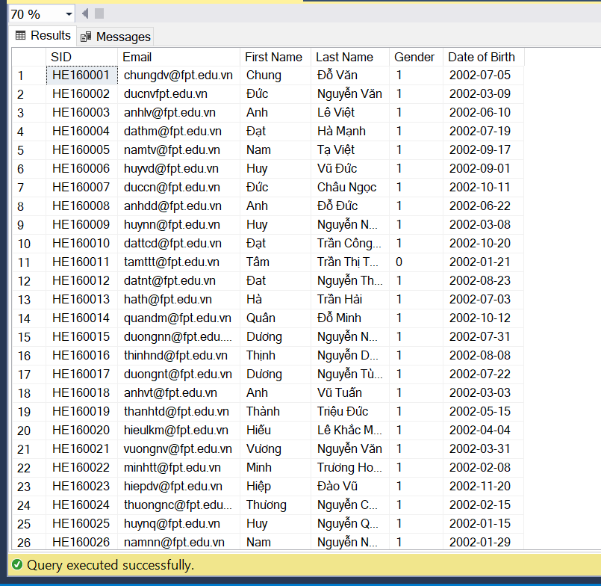

* **SELECT * FROM Groups**

INSERT Groups(GID, Major, [Num of Students]) VALUES ('IA1604', 'Information Assurance', 30);

INSERT Groups(GID, Major, [Num of Students]) VALUES ('AI1606', 'Artificial Intelligence', 28);

INSERT Groups(GID, Major, [Num of Students]) VALUES ('SE1636', 'Software Engineering', 25);

INSERT Groups(GID, Major, [Num of Students]) VALUES ('IOT1602', 'Internet of Things', 30);

INSERT Groups(GID, Major, [Num of Students]) VALUES ('AI1601', 'Artificial Intelligence', 29);

INSERT Groups(GID, Major, [Num of Students]) VALUES ('IA1601', 'Information Assurance', 27);

INSERT Groups(GID, Major, [Num of Students]) VALUES ('SE1643', 'Software Engineering', 29);

INSERT Groups(GID, Major, [Num of Students]) VALUES ('IA1602', 'Information Assurance', 26);

INSERT Groups(GID, Major, [Num of Students]) VALUES ('IS1603', 'Information Specialization', 25);

INSERT Groups(GID, Major, [Num of Students]) VALUES ('SE1637', 'Software Engineering', 28);

* **Image result**

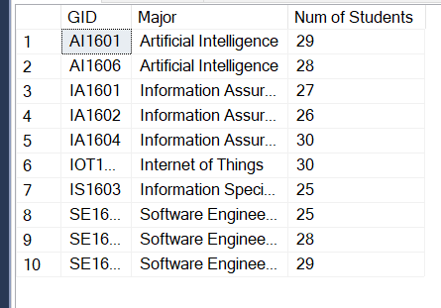

* **SELECT * FROM [Join]**

INSERT [Join](SID, GID) VALUES ('HE160001', 'IA1604');

INSERT [Join](SID, GID) VALUES ('HE160002', 'IA1604');

INSERT [Join](SID, GID) VALUES ('HE160003', 'IA1604');

INSERT [Join](SID, GID) VALUES ('HE160004', 'IA1604');

INSERT [Join](SID, GID) VALUES ('HE160005', 'IA1604');

INSERT [Join](SID, GID) VALUES ('HE160006', 'IA1604');

INSERT [Join](SID, GID) VALUES ('HE160007', 'IA1604');

INSERT [Join](SID, GID) VALUES ('HE160008', 'IA1604');

INSERT [Join](SID, GID) VALUES ('HE160009', 'IA1604');

INSERT [Join](SID, GID) VALUES ('HE160010', 'IA1604');

INSERT [Join](SID, GID) VALUES ('HE160011', 'AI1606');

INSERT [Join](SID, GID) VALUES ('HE160012', 'AI1606');

INSERT [Join](SID, GID) VALUES ('HE160013', 'AI1606');

INSERT [Join](SID, GID) VALUES ('HE160014', 'AI1606');

INSERT [Join](SID, GID) VALUES ('HE160015', 'AI1606');

INSERT [Join](SID, GID) VALUES ('HE160016', 'AI1606');

INSERT [Join](SID, GID) VALUES ('HE160017', 'AI1606');

INSERT [Join](SID, GID) VALUES ('HE160018', 'AI1606');

INSERT [Join](SID, GID) VALUES ('HE160019', 'AI1606');

INSERT [Join](SID, GID) VALUES ('HE160020', 'AI1606');

INSERT [Join](SID, GID) VALUES ('HE160021', 'SE1636');

INSERT [Join](SID, GID) VALUES ('HE160022', 'SE1636');

INSERT [Join](SID, GID) VALUES ('HE160023', 'SE1636');

INSERT [Join](SID, GID) VALUES ('HE160024', 'SE1636');

INSERT [Join](SID, GID) VALUES ('HE160025', 'SE1636');

INSERT [Join](SID, GID) VALUES ('HE160026', 'SE1636');

INSERT [Join](SID, GID) VALUES ('HE160027', 'SE1636');

INSERT [Join](SID, GID) VALUES ('HE160028', 'SE1636');

INSERT [Join](SID, GID) VALUES ('HE160029', 'SE1636');

INSERT [Join](SID, GID) VALUES ('HE160030', 'SE1636');

INSERT [Join](SID, GID) VALUES ('HE160031', 'IOT1602');

INSERT [Join](SID, GID) VALUES ('HE160032', 'IOT1602');

INSERT [Join](SID, GID) VALUES ('HE160033', 'IOT1602');

INSERT [Join](SID, GID) VALUES ('HE160034', 'IOT1602');

INSERT [Join](SID, GID) VALUES ('HE160035', 'IOT1602');

INSERT [Join](SID, GID) VALUES ('HE160036', 'IOT1602');

INSERT [Join](SID, GID) VALUES ('HE160037', 'IOT1602');

INSERT [Join](SID, GID) VALUES ('HE160038', 'IOT1602');

INSERT [Join](SID, GID) VALUES ('HE160039', 'IOT1602');

INSERT [Join](SID, GID) VALUES ('HE160040', 'IOT1602');

INSERT [Join](SID, GID) VALUES ('HE160041', 'IS1603');

INSERT [Join](SID, GID) VALUES ('HE160042', 'IS1603');

INSERT [Join](SID, GID) VALUES ('HE160043', 'IS1603');

INSERT [Join](SID, GID) VALUES ('HE160044', 'IS1603');

INSERT [Join](SID, GID) VALUES ('HE160045', 'IS1603');

INSERT [Join](SID, GID) VALUES ('HE160046', 'IS1603');

INSERT [Join](SID, GID) VALUES ('HE160047', 'IS1603');

INSERT [Join](SID, GID) VALUES ('HE160048', 'IS1603');

INSERT [Join](SID, GID) VALUES ('HE160049', 'IS1603');

INSERT [Join](SID, GID) VALUES ('HE160050', 'IS1603');

* **Image result**

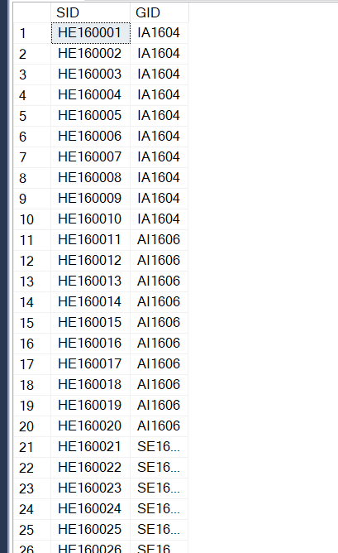

* **SELECT * FROM Lectures**

INSERT Lectures(LecID, Email, [First Name], [Last Name], Gender, [Date of Birth], Report) VALUES ('GVA', 'khuongpd@fe.edu.vn', N'Khương', N'Phùng Duy', 1, CAST('1991-05-19' AS date), NULL);

INSERT Lectures(LecID, Email, [First Name], [Last Name], Gender, [Date of Birth], Report) VALUES ('GVB', 'anhbn@fe.edu.vn', N'Anh', N'Bùi Ngọc', 0, CAST('1992-06-10' AS date), 'GVA');

INSERT Lectures(LecID, Email, [First Name], [Last Name], Gender, [Date of Birth], Report) VALUES ('GVC', 'phuonglh@fe.edu.vn', N'Phương', N'Lại Hiền', 0, CAST('1988-03-01' AS date), 'GVA');

INSERT Lectures(LecID, Email, [First Name], [Last Name], Gender, [Date of Birth], Report) VALUES ('GVG', 'chilp@fe.edu.vn', N'Lê', N'Phương Chi', 0, CAST('1989-09-01' AS date), 'GVF');

INSERT Lectures(LecID, Email, [First Name], [Last Name], Gender, [Date of Birth], Report) VALUES ('GVH', 'cuonghd@fe.edu.vn', N'Cường', N'Hoàng Đình', 1, CAST('1990-08-12' AS date), NULL);

INSERT Lectures(LecID, Email, [First Name], [Last Name], Gender, [Date of Birth], Report) VALUES ('GVI', 'sonnt@fe.edu.vn', N'Sơn', N'Ngô Tùng', 1, CAST('1980-10-21' AS date), 'GVH');

INSERT Lectures(LecID, Email, [First Name], [Last Name], Gender, [Date of Birth], Report) VALUES ('GVJ', 'tientd@fe.edu.vn', N'Tiến', N'Tạ Đình', 1, CAST('1987-05-24' AS date), 'GVH');

INSERT Lectures(LecID, Email, [First Name], [Last Name], Gender, [Date of Birth], Report) VALUES ('GVK', 'bantq@fe.edu.vn', N'Ban', N'Trần Quý', 1, CAST('1986-12-31' AS date), 'GVH');

* **Image result**

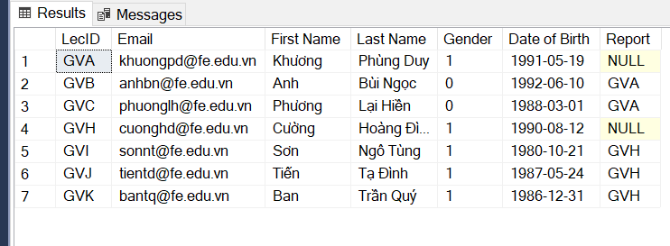

* **SELECT * FROM Courses**

INSERT [dbo].[Courses]([CourseID], [CourseName]) VALUES (N'CSD201', N'Data Structures and Algorithms');

INSERT [dbo].[Courses]([CourseID], [CourseName]) VALUES (N'DBI202', N'Introduction to Databases');

INSERT [dbo].[Courses]([CourseID], [CourseName]) VALUES (N'LAB211', N'OOP with Java Labs');

INSERT [dbo].[Courses]([CourseID], [CourseName]) VALUES (N'IAO202', N'Introduction to Infor Assurance');

INSERT [dbo].[Courses]([CourseID], [CourseName]) VALUES (N'JPD113', N'Elementary Japanese 1-A1.1');

* **Image result**

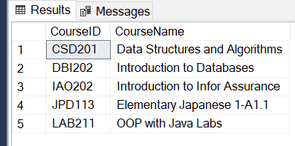

* **SELECT * FROM Assignment**

INSERT Assignment(AssignID, Major, Lecture) VALUES ('DBI1', 'DBI202', 'GVA');

INSERT Assignment(AssignID, Major, Lecture) VALUES ('DBI2', 'DBI202', 'GVB');

INSERT Assignment(AssignID, Major, Lecture) VALUES ('JPD3', 'JPD113', 'GVC');

INSERT Assignment(AssignID, Major, Lecture) VALUES ('IAO1', 'IAO202', 'GVJ');

INSERT Assignment(AssignID, Major, Lecture) VALUES ('LAB1', 'LAB211', 'GVH');

INSERT Assignment(AssignID, Major, Lecture) VALUES ('IAO3', 'IAO202', 'GVI');

INSERT Assignment(AssignID, Major, Lecture) VALUES ('JPD1', 'JPD113', 'GVJ');

INSERT Assignment(AssignID, Major, Lecture) VALUES ('CSD1', 'CSD201', 'GVK');

INSERT Assignment(AssignID, Major, Lecture) VALUES ('JPD2', 'JPD113', 'GVA');

INSERT Assignment(AssignID, Major, Lecture) VALUES ('LAB2', 'LAB211', 'GVB');

INSERT Assignment(AssignID, Major, Lecture) VALUES ('DBI3', 'DBI202', 'GVC');

INSERT Assignment(AssignID, Major, Lecture) VALUES ('LAB3', 'LAB211', 'GVA');

INSERT Assignment(AssignID, Major, Lecture) VALUES ('CSD2', 'CSD201', 'GVH');

INSERT Assignment(AssignID, Major, Lecture) VALUES ('IAO2', 'IAO202', 'GVJ');

* **Image result**

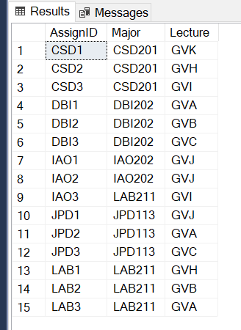

* **SELECT * FROM Classes**

INSERT Classes(ClassID, AssignID, Semester, [Start Date], [End Date]) VALUES ('SP22IAO1', 'IAO1', 'SPRING 2022', CAST('2022-05-09' AS date), CAST('2022-07-25' AS date));

INSERT Classes(ClassID, AssignID, Semester, [Start Date], [End Date]) VALUES ('SP22DBI1', 'DBI1', 'SPRING 2022', CAST('2022-05-09' AS date), CAST('2022-07-25' AS date));

INSERT Classes(ClassID, AssignID, Semester, [Start Date], [End Date]) VALUES ('SP22CSD2', 'CSD2', 'SPRING 2022', CAST('2022-05-09' AS date), CAST('2022-07-25' AS date));

INSERT Classes(ClassID, AssignID, Semester, [Start Date], [End Date]) VALUES ('SP22JPD3', 'JPD3', 'SPRING 2022', CAST('2022-05-09' AS date), CAST('2022-07-25' AS date));

INSERT Classes(ClassID, AssignID, Semester, [Start Date], [End Date]) VALUES ('SP22IAO2', 'IAO2', 'SPRING 2022', CAST('2022-05-09' AS date), CAST('2022-07-25' AS date));

INSERT Classes(ClassID, AssignID, Semester, [Start Date], [End Date]) VALUES ('SP22LAB1', 'LAB1', 'SPRING 2022', CAST('2022-05-09' AS date), CAST('2022-07-25' AS date));

INSERT Classes(ClassID, AssignID, Semester, [Start Date], [End Date]) VALUES ('SP22CSD3', 'CSD3', 'SPRING 2022', CAST('2022-05-09' AS date), CAST('2022-07-25' AS date));

INSERT Classes(ClassID, AssignID, Semester, [Start Date], [End Date]) VALUES ('SP22IAO3', 'IAO3', 'SPRING 2022', CAST('2022-05-09' AS date), CAST('2022-07-25' AS date));

INSERT Classes(ClassID, AssignID, Semester, [Start Date], [End Date]) VALUES ('SP22LAB2', 'LAB2', 'SPRING 2022', CAST('2022-05-09' AS date), CAST('2022-07-25' AS date));

INSERT Classes(ClassID, AssignID, Semester, [Start Date], [End Date]) VALUES ('SP22DBI2', 'DBI2', 'SPRING 2022', CAST('2022-05-09' AS date), CAST('2022-07-25' AS date));

INSERT Classes(ClassID, AssignID, Semester, [Start Date], [End Date]) VALUES ('FA21LAB1', 'LAB1', 'FALL 2021', CAST('2021-01-09' AS date), CAST('2021-04-08' AS date));

INSERT Classes(ClassID, AssignID, Semester, [Start Date], [End Date]) VALUES ('FA21JPD1', 'JPD1', 'FALL 2021', CAST('2021-01-09' AS date), CAST('2021-04-08' AS date));

INSERT Classes(ClassID, AssignID, Semester, [Start Date], [End Date]) VALUES ('FA21DBI1', 'DBI1', 'FALL 2021', CAST('2021-01-09' AS date), CAST('2021-04-08' AS date));

INSERT Classes(ClassID, AssignID, Semester, [Start Date], [End Date]) VALUES ('FA21IAO1', 'IAO1', 'FALL 2021', CAST('2021-01-09' AS date), CAST('2021-04-08' AS date));

INSERT Classes(ClassID, AssignID, Semester, [Start Date], [End Date]) VALUES ('FA21CSD1', 'CSD1', 'FALL 2021', CAST('2021-01-09' AS date), CAST('2021-04-08' AS date));

INSERT Classes(ClassID, AssignID, Semester, [Start Date], [End Date]) VALUES ('FA21DBI3', 'DBI3', 'FALL 2021', CAST('2021-01-09' AS date), CAST('2021-04-08' AS date));

INSERT Classes(ClassID, AssignID, Semester, [Start Date], [End Date]) VALUES ('FA21LAB2', 'LAB2', 'FALL 2021', CAST('2021-01-09' AS date), CAST('2021-04-08' AS date));

INSERT Classes(ClassID, AssignID, Semester, [Start Date], [End Date]) VALUES ('FA21JPD2', 'JPD2', 'FALL 2021', CAST('2021-01-09' AS date), CAST('2021-04-08' AS date));

INSERT Classes(ClassID, AssignID, Semester, [Start Date], [End Date]) VALUES ('FA21IAO3', 'IAO3', 'FALL 2021', CAST('2021-01-09' AS date), CAST('2021-04-08' AS date));

INSERT Classes(ClassID, AssignID, Semester, [Start Date], [End Date]) VALUES ('FA21CSD3', 'CSD3', 'FALL 2021', CAST('2021-01-09' AS date), CAST('2021-04-08' AS date));

INSERT Classes(ClassID, AssignID, Semester, [Start Date], [End Date]) VALUES ('SU21IAO2', 'IAO2', 'SUMMER 2021', CAST('2021-04-16' AS date), CAST('2021-07-26' AS date));

INSERT Classes(ClassID, AssignID, Semester, [Start Date], [End Date]) VALUES ('SU21JPD3', 'JPD3', 'SUMMER 2021', CAST('2021-04-16' AS date), CAST('2021-07-26' AS date));

INSERT Classes(ClassID, AssignID, Semester, [Start Date], [End Date]) VALUES ('SU21IAO3', 'IAO3', 'SUMMER 2021', CAST('2021-04-16' AS date), CAST('2021-07-26' AS date));

INSERT Classes(ClassID, AssignID, Semester, [Start Date], [End Date]) VALUES ('SU21LAB2', 'LAB2', 'SUMMER 2021', CAST('2021-04-16' AS date), CAST('2021-07-26' AS date));

INSERT Classes(ClassID, AssignID, Semester, [Start Date], [End Date]) VALUES ('SU21LAB1', 'LAB1', 'SUMMER 2021', CAST('2021-04-16' AS date), CAST('2021-07-26' AS date));

INSERT Classes(ClassID, AssignID, Semester, [Start Date], [End Date]) VALUES ('SU21CSD3', 'CSD3', 'SUMMER 2021', CAST('2021-04-16' AS date), CAST('2021-07-26' AS date));

INSERT Classes(ClassID, AssignID, Semester, [Start Date], [End Date]) VALUES ('SU21DBI1', 'DBI1', 'SUMMER 2021', CAST('2021-04-16' AS date), CAST('2021-07-26' AS date));

INSERT Classes(ClassID, AssignID, Semester, [Start Date], [End Date]) VALUES ('SU21CSD2', 'CSD2', 'SUMMER 2021', CAST('2021-04-16' AS date), CAST('2021-07-26' AS date));

INSERT Classes(ClassID, AssignID, Semester, [Start Date], [End Date]) VALUES ('SU21JPD1', 'JPD1', 'SUMMER 2021', CAST('2021-04-16' AS date), CAST('2021-07-26' AS date));

INSERT Classes(ClassID, AssignID, Semester, [Start Date], [End Date]) VALUES ('SU21DBI3', 'DBI3', 'SUMMER 2021', CAST('2021-04-16' AS date), CAST('2021-07-26' AS date));

INSERT Classes(ClassID, AssignID, Semester, [Start Date], [End Date]) VALUES ('SU21CSD1', 'CSD1', 'SUMMER 2021', CAST('2021-04-16' AS date), CAST('2021-07-26' AS date));

* **Image result**

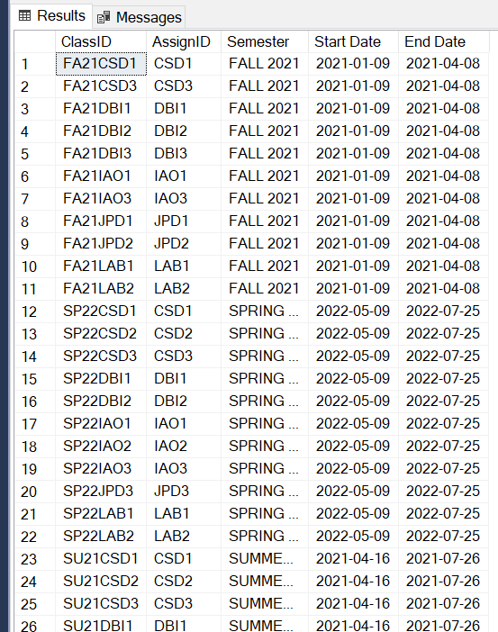

* **SELECT * FROM Enroll**

INSERT Enroll(ClassID, GID) VALUES ('SP22CSD1', 'IA1604');

INSERT Enroll(ClassID, GID) VALUES ('SU21CSD2', 'IA1604');

INSERT Enroll(ClassID, GID) VALUES ('FA21IAO3', 'IA1604');

INSERT Enroll(ClassID, GID) VALUES ('SP22LAB2', 'IA1604');

INSERT Enroll(ClassID, GID) VALUES ('SU21CSD3', 'IA1604');

INSERT Enroll(ClassID, GID) VALUES ('SP22IAO1', 'AI1606');

INSERT Enroll(ClassID, GID) VALUES ('FA21LAB2', 'AI1606');

INSERT Enroll(ClassID, GID) VALUES ('SP22LAB1', 'AI1606');

INSERT Enroll(ClassID, GID) VALUES ('FA21JPD2', 'AI1606');

INSERT Enroll(ClassID, GID) VALUES ('SP22JPD3', 'AI1606');

INSERT Enroll(ClassID, GID) VALUES ('SU21DBI3', 'SE1636');

INSERT Enroll(ClassID, GID) VALUES ('FA21CSD1', 'SE1636');

INSERT Enroll(ClassID, GID) VALUES ('SP22IAO2', 'SE1636');

INSERT Enroll(ClassID, GID) VALUES ('SU21LAB1', 'SE1636');

INSERT Enroll(ClassID, GID) VALUES ('FA21JPD1', 'SE1636');

INSERT Enroll(ClassID, GID) VALUES ('SP22JPD3', 'IOT1602');

INSERT Enroll(ClassID, GID) VALUES ('SU21CSD1', 'IOT1602');

INSERT Enroll(ClassID, GID) VALUES ('SP22LAB1', 'IOT1602');

INSERT Enroll(ClassID, GID) VALUES ('FA21CSD3', 'IOT1602');

INSERT Enroll(ClassID, GID) VALUES ('SU21DBI3', 'IOT1602');

INSERT Enroll(ClassID, GID) VALUES ('FA21LAB1', 'IS1603');

INSERT Enroll(ClassID, GID) VALUES ('SU21IAO2', 'IS1603');

INSERT Enroll(ClassID, GID) VALUES ('FA21LAB2', 'IS1603');

INSERT Enroll(ClassID, GID) VALUES ('SP22CSD2', 'IS1603');

INSERT Enroll(ClassID, GID) VALUES ('SU21DBI1', 'IS1603');

* **Image result**

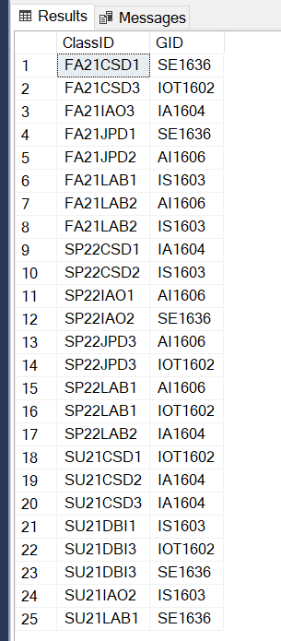

* **SELECT * FROM Categories**

INSERT Categories(CategoryID, [CategoryName], [Type], [Completion Criteria]) VALUES ('AS', 'Assignment ', 'On-Going', '>0');

INSERT Categories(CategoryID, [CategoryName], [Type], [Completion Criteria]) VALUES ('LAB', 'Lab', 'On-Going', '>0');

INSERT Categories(CategoryID, [CategoryName], [Type], [Completion Criteria]) VALUES ('LOC', 'Line of Code', 'On-Going', '>=750');

INSERT Categories(CategoryID, [CategoryName], [Type], [Completion Criteria]) VALUES ('PT', 'Progress Test', 'On-Going', '>0');

INSERT Categories(CategoryID, [CategoryName], [Type], [Completion Criteria]) VALUES ('PE', 'Practical Exam', 'On-Going', '>0');

INSERT Categories(CategoryID, [CategoryName], [Type], [Completion Criteria]) VALUES ('FE', 'Final Exam', 'Final Exam', '>4');

INSERT Categories(CategoryID, [CategoryName], [Type], [Completion Criteria]) VALUES ('FER', 'Final Exam Retake', 'Final Exam', '>4');

* **Image result**

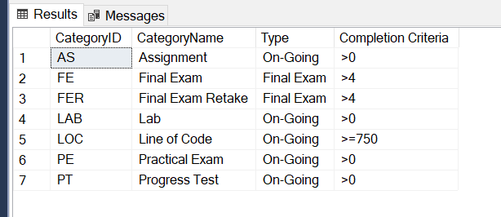

* **SELECT * FROM Assessment System**

INSERT [Assessment System](AssessID, CategoryID, CourseID, [Num of Ques], Duration, [Weight]) VALUES ('CSDAS1', 'AS', 'CSD201', 20, '30 mins', 0.1);

INSERT [Assessment System](AssessID, CategoryID, CourseID, [Num of Ques], Duration, [Weight]) VALUES ('CSDAS2', 'AS', 'CSD201', 20, '30 mins', 0.1);

INSERT [Assessment System](AssessID, CategoryID, CourseID, [Num of Ques], Duration, [Weight]) VALUES ('CSDPT1', 'PT', 'CSD201', 30, '30 mins', 0.1);

INSERT [Assessment System](AssessID, CategoryID, CourseID, [Num of Ques], Duration, [Weight]) VALUES ('CSDPT2', 'PT', 'CSD201', 30, '30 mins', 0.1);

INSERT [Assessment System](AssessID, CategoryID, CourseID, [Num of Ques], Duration, [Weight]) VALUES ('CSDPE', 'PE', 'CSD201', 10, '90 mins', 0.3);

INSERT [Assessment System](AssessID, CategoryID, CourseID, [Num of Ques], Duration, [Weight]) VALUES ('CSDFE', 'FE', 'CSD201', 50, '60 mins', 0.1);

INSERT [Assessment System](AssessID, CategoryID, CourseID, [Num of Ques], Duration, [Weight]) VALUES ('DBIAS1', 'AS', 'DBI202', 20, '30 mins', 0.1);

INSERT [Assessment System](AssessID, CategoryID, CourseID, [Num of Ques], Duration, [Weight]) VALUES ('DBIAS2', 'AS', 'DBI202', 20, '30 mins', 0.1);

INSERT [Assessment System](AssessID, CategoryID, CourseID, [Num of Ques], Duration, [Weight]) VALUES ('DBIPT1', 'PT', 'DBI202', 20, '30 mins', 0.1);

INSERT [Assessment System](AssessID, CategoryID, CourseID, [Num of Ques], Duration, [Weight]) VALUES ('DBIPT2', 'PT', 'DBI202', 20, '30 mins', 0.1);

INSERT [Assessment System](AssessID, CategoryID, CourseID, [Num of Ques], Duration, [Weight]) VALUES ('DBIPE', 'PE', 'DBI202', 10, '90 mins', 0.3);

INSERT [Assessment System](AssessID, CategoryID, CourseID, [Num of Ques], Duration, [Weight]) VALUES ('DBIFE', 'FE', 'DBI202', 50, '60 mins', 0.3);

INSERT [Assessment System](AssessID, CategoryID, CourseID, [Num of Ques], Duration, [Weight]) VALUES ('LABLOC', 'LOC', 'LAB211', 750, '30 SLOTS', 1);

INSERT [Assessment System](AssessID, CategoryID, CourseID, [Num of Ques], Duration, [Weight]) VALUES ('IAOLAB1', 'LAB', 'IAO202', 5, '30 mins', 0.05);

INSERT [Assessment System](AssessID, CategoryID, CourseID, [Num of Ques], Duration, [Weight]) VALUES ('IAOLAB2', 'LAB', 'IAO202', 5, '30 mins', 0.05);

INSERT [Assessment System](AssessID, CategoryID, CourseID, [Num of Ques], Duration, [Weight]) VALUES ('IAOLAB3', 'LAB', 'IAO202', 5, '30 mins', 0.05);

INSERT [Assessment System](AssessID, CategoryID, CourseID, [Num of Ques], Duration, [Weight]) VALUES ('IAOLAB4', 'LAB', 'IAO202', 5, '30 mins', 0.05);

INSERT [Assessment System](AssessID, CategoryID, CourseID, [Num of Ques], Duration, [Weight]) VALUES ('IAOLAB5', 'LAB', 'IAO202', 5, '30 mins', 0.05);

INSERT [Assessment System](AssessID, CategoryID, CourseID, [Num of Ques], Duration, [Weight]) VALUES ('IAOLAB6', 'LAB', 'IAO202', 5, '30 mins', 0.05);

INSERT [Assessment System](AssessID, CategoryID, CourseID, [Num of Ques], Duration, [Weight]) VALUES ('IAOLAB7', 'LAB', 'IAO202', 5, '30 mins', 0.05);

INSERT [Assessment System](AssessID, CategoryID, CourseID, [Num of Ques], Duration, [Weight]) VALUES ('IAOLAB8', 'LAB', 'IAO202', 5, '30 mins', 0.05);

INSERT [Assessment System](AssessID, CategoryID, CourseID, [Num of Ques], Duration, [Weight]) VALUES ('IAOLAB9', 'LAB', 'IAO202', 5, '30 mins', 0.05);

INSERT [Assessment System](AssessID, CategoryID, CourseID, [Num of Ques], Duration, [Weight]) VALUES ('IAOLAB10', 'LAB', 'IAO202', 5, '30 mins', 0.05);

INSERT [Assessment System](AssessID, CategoryID, CourseID, [Num of Ques], Duration, [Weight]) VALUES ('IAOPT1', 'PT', 'IAO202', 30, '60 mins', 0.1);

INSERT [Assessment System](AssessID, CategoryID, CourseID, [Num of Ques], Duration, [Weight]) VALUES ('IAOPT2', 'PT', 'IAO202', 30, '60 mins', 0.1);

INSERT [Assessment System](AssessID, CategoryID, CourseID, [Num of Ques], Duration, [Weight]) VALUES ('IAOFE', 'FE', 'IAO202', 60, '90 mins', 0.3);

INSERT [Assessment System](AssessID, CategoryID, CourseID, [Num of Ques], Duration, [Weight]) VALUES ('JPDAS1', 'AS', 'JPD113', 40, '30 mins', 0.1);

INSERT [Assessment System](AssessID, CategoryID, CourseID, [Num of Ques], Duration, [Weight]) VALUES ('JPDAS2', 'AS', 'JPD113', 40, '30 mins', 0.1);

INSERT [Assessment System](AssessID, CategoryID, CourseID, [Num of Ques], Duration, [Weight]) VALUES ('JPDPT1', 'PT', 'JPD113', 40, '30 mins', 0.2);

INSERT [Assessment System](AssessID, CategoryID, CourseID, [Num of Ques], Duration, [Weight]) VALUES ('JPDPT2', 'PT', 'JPD113', 40, '30 mins', 0.2);

INSERT [Assessment System](AssessID, CategoryID, CourseID, [Num of Ques], Duration, [Weight]) VALUES ('JPDFE', 'FE', 'JPD113', 50, '60 mins', 0.4);

* **Image result**

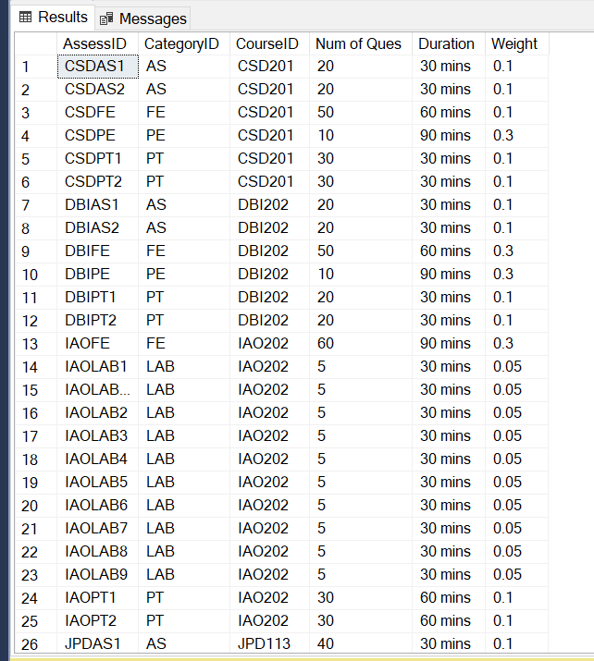

* **SELECT * FROM Assess**

INSERT Assess(AssessID, ClassID) VALUES ('DBIAS1', 'FA21DBI1');

INSERT Assess(AssessID, ClassID) VALUES ('DBIAS2', 'FA21DBI1');

INSERT Assess(AssessID, ClassID) VALUES ('DBIPT1', 'FA21DBI1');

INSERT Assess(AssessID, ClassID) VALUES ('DBIPT2', 'FA21DBI1');

INSERT Assess(AssessID, ClassID) VALUES ('DBIPE', 'FA21DBI1');

INSERT Assess(AssessID, ClassID) VALUES ('DBIFE', 'FA21DBI1');

INSERT Assess(AssessID, ClassID) VALUES ('CSDAS1', 'FA21CSD1');

INSERT Assess(AssessID, ClassID) VALUES ('CSDAS2', 'FA21CSD1');

INSERT Assess(AssessID, ClassID) VALUES ('CSDPT1', 'FA21CSD1');

INSERT Assess(AssessID, ClassID) VALUES ('CSDPT2', 'FA21CSD1');

INSERT Assess(AssessID, ClassID) VALUES ('CSDPE', 'FA21CSD1');

INSERT Assess(AssessID, ClassID) VALUES ('CSDFE', 'FA21CSD1');

INSERT Assess(AssessID, ClassID) VALUES ('IAOLAB1', 'FA21IAO1');

INSERT Assess(AssessID, ClassID) VALUES ('IAOLAB2', 'FA21IAO1');

INSERT Assess(AssessID, ClassID) VALUES ('IAOLAB3', 'FA21IAO1');

INSERT Assess(AssessID, ClassID) VALUES ('IAOLAB4', 'FA21IAO1');

INSERT Assess(AssessID, ClassID) VALUES ('IAOLAB5', 'FA21IAO1');

INSERT Assess(AssessID, ClassID) VALUES ('IAOLAB6', 'FA21IAO1');

INSERT Assess(AssessID, ClassID) VALUES ('IAOLAB7', 'FA21IAO1');

INSERT Assess(AssessID, ClassID) VALUES ('IAOLAB8', 'FA21IAO1');

INSERT Assess(AssessID, ClassID) VALUES ('IAOLAB9', 'FA21IAO1');

INSERT Assess(AssessID, ClassID) VALUES ('IAOLAB10', 'FA21IAO1');

INSERT Assess(AssessID, ClassID) VALUES ('IAOPT1', 'FA21IAO1');

INSERT Assess(AssessID, ClassID) VALUES ('IAOPT2', 'FA21IAO1');

INSERT Assess(AssessID, ClassID) VALUES ('IAOFE', 'FA21IAO1');

INSERT Assess(AssessID, ClassID) VALUES ('JPDAS1', 'FA21JPD1');

INSERT Assess(AssessID, ClassID) VALUES ('JPDAS2', 'FA21JPD1');

INSERT Assess(AssessID, ClassID) VALUES ('JPDPT1', 'FA21JPD1');

INSERT Assess(AssessID, ClassID) VALUES ('JPDPT2', 'FA21JPD1');

INSERT Assess(AssessID, ClassID) VALUES ('JPDFE', 'FA21JPD1');

INSERT Assess(AssessID, ClassID) VALUES ('LABLOC', 'FA21LAB1');

INSERT Assess(AssessID, ClassID) VALUES ('DBIAS1', 'FA21DBI2');

INSERT Assess(AssessID, ClassID) VALUES ('DBIAS2', 'FA21DBI2');

INSERT Assess(AssessID, ClassID) VALUES ('DBIPT1', 'FA21DBI2');

INSERT Assess(AssessID, ClassID) VALUES ('DBIPT2', 'FA21DBI2');

INSERT Assess(AssessID, ClassID) VALUES ('DBIPE', 'FA21DBI2');

INSERT Assess(AssessID, ClassID) VALUES ('DBIFE', 'FA21DBI2');

INSERT Assess(AssessID, ClassID) VALUES ('JPDAS1', 'FA21JPD2');

INSERT Assess(AssessID, ClassID) VALUES ('JPDAS2', 'FA21JPD2');

INSERT Assess(AssessID, ClassID) VALUES ('JPDPT1', 'FA21JPD2');

INSERT Assess(AssessID, ClassID) VALUES ('JPDPT2', 'FA21JPD2');

INSERT Assess(AssessID, ClassID) VALUES ('JPDFE', 'FA21JPD2');

INSERT Assess(AssessID, ClassID) VALUES ('LABLOC', 'FA21LAB2');

INSERT Assess(AssessID, ClassID) VALUES ('IAOLAB1', 'FA21IAO3');

INSERT Assess(AssessID, ClassID) VALUES ('IAOLAB2', 'FA21IAO3');

INSERT Assess(AssessID, ClassID) VALUES ('IAOLAB3', 'FA21IAO3');

INSERT Assess(AssessID, ClassID) VALUES ('IAOLAB4', 'FA21IAO3');

INSERT Assess(AssessID, ClassID) VALUES ('IAOLAB5', 'FA21IAO3');

INSERT Assess(AssessID, ClassID) VALUES ('IAOLAB6', 'FA21IAO3');

INSERT Assess(AssessID, ClassID) VALUES ('IAOLAB7', 'FA21IAO3');

INSERT Assess(AssessID, ClassID) VALUES ('IAOLAB8', 'FA21IAO3');

INSERT Assess(AssessID, ClassID) VALUES ('IAOLAB9', 'FA21IAO3');

INSERT Assess(AssessID, ClassID) VALUES ('IAOLAB10', 'FA21IAO3');

INSERT Assess(AssessID, ClassID) VALUES ('IAOPT1', 'FA21IAO3');

INSERT Assess(AssessID, ClassID) VALUES ('IAOPT2', 'FA21IAO3');

INSERT Assess(AssessID, ClassID) VALUES ('IAOFE', 'FA21IAO3');

INSERT Assess(AssessID, ClassID) VALUES ('CSDAS1', 'FA21CSD3');

INSERT Assess(AssessID, ClassID) VALUES ('CSDAS2', 'FA21CSD3');

INSERT Assess(AssessID, ClassID) VALUES ('CSDPT1', 'FA21CSD3');

INSERT Assess(AssessID, ClassID) VALUES ('CSDPT2', 'FA21CSD3');

INSERT Assess(AssessID, ClassID) VALUES ('CSDPE', 'FA21CSD3');

INSERT Assess(AssessID, ClassID) VALUES ('CSDFE', 'FA21CSD3');

INSERT Assess(AssessID, ClassID) VALUES ('DBIAS1', 'FA21DBI3');

INSERT Assess(AssessID, ClassID) VALUES ('DBIAS2', 'FA21DBI3');

INSERT Assess(AssessID, ClassID) VALUES ('DBIPT1', 'FA21DBI3');

INSERT Assess(AssessID, ClassID) VALUES ('DBIPT2', 'FA21DBI3');

INSERT Assess(AssessID, ClassID) VALUES ('DBIPE', 'FA21DBI3');

INSERT Assess(AssessID, ClassID) VALUES ('DBIFE', 'FA21DBI3');

INSERT Assess(AssessID, ClassID) VALUES ('DBIAS1', 'SU21DBI1');

INSERT Assess(AssessID, ClassID) VALUES ('DBIAS2', 'SU21DBI1');

INSERT Assess(AssessID, ClassID) VALUES ('DBIPT1', 'SU21DBI1');

INSERT Assess(AssessID, ClassID) VALUES ('DBIPT2', 'SU21DBI1');

INSERT Assess(AssessID, ClassID) VALUES ('DBIPE', 'SU21DBI1');

INSERT Assess(AssessID, ClassID) VALUES ('DBIFE', 'SU21DBI1');

INSERT Assess(AssessID, ClassID) VALUES ('CSDAS1', 'SU21CSD1');

INSERT Assess(AssessID, ClassID) VALUES ('CSDAS2', 'SU21CSD1');

INSERT Assess(AssessID, ClassID) VALUES ('CSDPT1', 'SU21CSD1');

INSERT Assess(AssessID, ClassID) VALUES ('CSDPT2', 'SU21CSD1');

INSERT Assess(AssessID, ClassID) VALUES ('CSDPE', 'SU21CSD1');

INSERT Assess(AssessID, ClassID) VALUES ('CSDFE', 'SU21CSD1');

INSERT Assess(AssessID, ClassID) VALUES ('IAOLAB1', 'SU21IAO1');

INSERT Assess(AssessID, ClassID) VALUES ('IAOLAB2', 'SU21IAO1');

INSERT Assess(AssessID, ClassID) VALUES ('IAOLAB3', 'SU21IAO1');

INSERT Assess(AssessID, ClassID) VALUES ('IAOLAB4', 'SU21IAO1');

INSERT Assess(AssessID, ClassID) VALUES ('IAOLAB5', 'SU21IAO1');

INSERT Assess(AssessID, ClassID) VALUES ('IAOLAB6', 'SU21IAO1');

INSERT Assess(AssessID, ClassID) VALUES ('IAOLAB7', 'SU21IAO1');

INSERT Assess(AssessID, ClassID) VALUES ('IAOLAB8', 'SU21IAO1');

INSERT Assess(AssessID, ClassID) VALUES ('IAOLAB9', 'SU21IAO1');

INSERT Assess(AssessID, ClassID) VALUES ('IAOLAB10', 'SU21IAO1');

INSERT Assess(AssessID, ClassID) VALUES ('IAOPT1', 'SU21IAO1');

INSERT Assess(AssessID, ClassID) VALUES ('IAOPT2', 'SU21IAO1');

INSERT Assess(AssessID, ClassID) VALUES ('IAOFE', 'SU21IAO1');

INSERT Assess(AssessID, ClassID) VALUES ('JPDAS1', 'SU21JPD1');

INSERT Assess(AssessID, ClassID) VALUES ('JPDAS2', 'SU21JPD1');

INSERT Assess(AssessID, ClassID) VALUES ('JPDPT1', 'SU21JPD1');

INSERT Assess(AssessID, ClassID) VALUES ('JPDPT2', 'SU21JPD1');

INSERT Assess(AssessID, ClassID) VALUES ('JPDFE', 'SU21JPD1');

INSERT Assess(AssessID, ClassID) VALUES ('LABLOC', 'SU21LAB1');

INSERT Assess(AssessID, ClassID) VALUES ('CSDAS1', 'SU21CSD2');

INSERT Assess(AssessID, ClassID) VALUES ('CSDAS2', 'SU21CSD2');

INSERT Assess(AssessID, ClassID) VALUES ('CSDPT1', 'SU21CSD2');

INSERT Assess(AssessID, ClassID) VALUES ('CSDPT2', 'SU21CSD2');

INSERT Assess(AssessID, ClassID) VALUES ('CSDPE', 'SU21CSD2');

INSERT Assess(AssessID, ClassID) VALUES ('CSDFE', 'SU21CSD2');

INSERT Assess(AssessID, ClassID) VALUES ('IAOLAB1', 'SU21IAO2');

INSERT Assess(AssessID, ClassID) VALUES ('IAOLAB2', 'SU21IAO2');

INSERT Assess(AssessID, ClassID) VALUES ('IAOLAB3', 'SU21IAO2');

INSERT Assess(AssessID, ClassID) VALUES ('IAOLAB4', 'SU21IAO2');

INSERT Assess(AssessID, ClassID) VALUES ('IAOLAB5', 'SU21IAO2');

INSERT Assess(AssessID, ClassID) VALUES ('IAOLAB6', 'SU21IAO2');

INSERT Assess(AssessID, ClassID) VALUES ('IAOLAB7', 'SU21IAO2');

INSERT Assess(AssessID, ClassID) VALUES ('IAOLAB8', 'SU21IAO2');

INSERT Assess(AssessID, ClassID) VALUES ('IAOLAB9', 'SU21IAO2');

INSERT Assess(AssessID, ClassID) VALUES ('IAOLAB10', 'SU21IAO2');

INSERT Assess(AssessID, ClassID) VALUES ('IAOPT1', 'SU21IAO2');

INSERT Assess(AssessID, ClassID) VALUES ('IAOPT2', 'SU21IAO2');

INSERT Assess(AssessID, ClassID) VALUES ('IAOFE', 'SU21IAO2');

INSERT Assess(AssessID, ClassID) VALUES ('LABLOC', 'SU21LAB2');

INSERT Assess(AssessID, ClassID) VALUES ('IAOLAB1', 'SU21IAO3');

INSERT Assess(AssessID, ClassID) VALUES ('IAOLAB2', 'SU21IAO3');

INSERT Assess(AssessID, ClassID) VALUES ('IAOLAB3', 'SU21IAO3');

INSERT Assess(AssessID, ClassID) VALUES ('IAOLAB4', 'SU21IAO3');

INSERT Assess(AssessID, ClassID) VALUES ('IAOLAB5', 'SU21IAO3');

INSERT Assess(AssessID, ClassID) VALUES ('IAOLAB6', 'SU21IAO3');

INSERT Assess(AssessID, ClassID) VALUES ('IAOLAB7', 'SU21IAO3');

INSERT Assess(AssessID, ClassID) VALUES ('IAOLAB8', 'SU21IAO3');

INSERT Assess(AssessID, ClassID) VALUES ('IAOLAB9', 'SU21IAO3');

INSERT Assess(AssessID, ClassID) VALUES ('IAOLAB10', 'SU21IAO3');

INSERT Assess(AssessID, ClassID) VALUES ('IAOPT1', 'SU21IAO3');

INSERT Assess(AssessID, ClassID) VALUES ('IAOPT2', 'SU21IAO3');

INSERT Assess(AssessID, ClassID) VALUES ('IAOFE', 'SU21IAO3');

INSERT Assess(AssessID, ClassID) VALUES ('DBIAS1', 'SU21DBI3');

INSERT Assess(AssessID, ClassID) VALUES ('DBIAS2', 'SU21DBI3');

INSERT Assess(AssessID, ClassID) VALUES ('DBIPT1', 'SU21DBI3');

INSERT Assess(AssessID, ClassID) VALUES ('DBIPT2', 'SU21DBI3');

INSERT Assess(AssessID, ClassID) VALUES ('DBIPE', 'SU21DBI3');

INSERT Assess(AssessID, ClassID) VALUES ('DBIFE', 'SU21DBI3');

INSERT Assess(AssessID, ClassID) VALUES ('CSDAS1', 'SU21CSD3');

INSERT Assess(AssessID, ClassID) VALUES ('CSDAS2', 'SU21CSD3');

INSERT Assess(AssessID, ClassID) VALUES ('CSDPT1', 'SU21CSD3');

INSERT Assess(AssessID, ClassID) VALUES ('CSDPT2', 'SU21CSD3');

INSERT Assess(AssessID, ClassID) VALUES ('CSDPE', 'SU21CSD3');

INSERT Assess(AssessID, ClassID) VALUES ('CSDFE', 'SU21CSD3');

INSERT Assess(AssessID, ClassID) VALUES ('JPDAS1', 'SU21JPD3');

INSERT Assess(AssessID, ClassID) VALUES ('JPDAS2', 'SU21JPD3');

INSERT Assess(AssessID, ClassID) VALUES ('JPDPT1', 'SU21JPD3');

INSERT Assess(AssessID, ClassID) VALUES ('JPDPT2', 'SU21JPD3');

INSERT Assess(AssessID, ClassID) VALUES ('JPDFE', 'SU21JPD3');

INSERT Assess(AssessID, ClassID) VALUES ('DBIAS1', 'SP22DBI1');

INSERT Assess(AssessID, ClassID) VALUES ('DBIAS2', 'SP22DBI1');

INSERT Assess(AssessID, ClassID) VALUES ('DBIPT1', 'SP22DBI1');

INSERT Assess(AssessID, ClassID) VALUES ('DBIPT2', 'SP22DBI1');

INSERT Assess(AssessID, ClassID) VALUES ('DBIPE', 'SP22DBI1');

INSERT Assess(AssessID, ClassID) VALUES ('DBIFE', 'SP22DBI1');

INSERT Assess(AssessID, ClassID) VALUES ('CSDAS1', 'SP22CSD1');

INSERT Assess(AssessID, ClassID) VALUES ('CSDAS2', 'SP22CSD1');

INSERT Assess(AssessID, ClassID) VALUES ('CSDPT1', 'SP22CSD1');

INSERT Assess(AssessID, ClassID) VALUES ('CSDPT2', 'SP22CSD1');

INSERT Assess(AssessID, ClassID) VALUES ('CSDPE', 'SP22CSD1');

INSERT Assess(AssessID, ClassID) VALUES ('CSDFE', 'SP22CSD1');

INSERT Assess(AssessID, ClassID) VALUES ('IAOLAB1', 'SP22IAO1');

INSERT Assess(AssessID, ClassID) VALUES ('IAOLAB2', 'SP22IAO1');

INSERT Assess(AssessID, ClassID) VALUES ('IAOLAB3', 'SP22IAO1');

INSERT Assess(AssessID, ClassID) VALUES ('IAOLAB4', 'SP22IAO1');

INSERT Assess(AssessID, ClassID) VALUES ('IAOLAB5', 'SP22IAO1');

INSERT Assess(AssessID, ClassID) VALUES ('IAOLAB6', 'SP22IAO1');

INSERT Assess(AssessID, ClassID) VALUES ('IAOLAB7', 'SP22IAO1');

INSERT Assess(AssessID, ClassID) VALUES ('IAOLAB8', 'SP22IAO1');

INSERT Assess(AssessID, ClassID) VALUES ('IAOLAB9', 'SP22IAO1');

INSERT Assess(AssessID, ClassID) VALUES ('IAOLAB10', 'SP22IAO1');

INSERT Assess(AssessID, ClassID) VALUES ('IAOPT1', 'SP22IAO1');

INSERT Assess(AssessID, ClassID) VALUES ('IAOPT2', 'SP22IAO1');

INSERT Assess(AssessID, ClassID) VALUES ('IAOFE', 'SP22IAO1');

INSERT Assess(AssessID, ClassID) VALUES ('LABLOC', 'SP22LAB1');

INSERT Assess(AssessID, ClassID) VALUES ('CSDAS1', 'SP22CSD2');

INSERT Assess(AssessID, ClassID) VALUES ('CSDAS2', 'SP22CSD2');

INSERT Assess(AssessID, ClassID) VALUES ('CSDPT1', 'SP22CSD2');

INSERT Assess(AssessID, ClassID) VALUES ('CSDPT2', 'SP22CSD2');

INSERT Assess(AssessID, ClassID) VALUES ('CSDPE', 'SP22CSD2');

INSERT Assess(AssessID, ClassID) VALUES ('CSDFE', 'SP22CSD2');

INSERT Assess(AssessID, ClassID) VALUES ('DBIAS1', 'SP22DBI2');

INSERT Assess(AssessID, ClassID) VALUES ('DBIAS2', 'SP22DBI2');

INSERT Assess(AssessID, ClassID) VALUES ('DBIPT1', 'SP22DBI2');

INSERT Assess(AssessID, ClassID) VALUES ('DBIPT2', 'SP22DBI2');

INSERT Assess(AssessID, ClassID) VALUES ('DBIPE', 'SP22DBI2');

INSERT Assess(AssessID, ClassID) VALUES ('DBIFE', 'SP22DBI2');

INSERT Assess(AssessID, ClassID) VALUES ('IAOLAB1', 'SP22IAO2');

INSERT Assess(AssessID, ClassID) VALUES ('IAOLAB2', 'SP22IAO2');

INSERT Assess(AssessID, ClassID) VALUES ('IAOLAB3', 'SP22IAO2');

INSERT Assess(AssessID, ClassID) VALUES ('IAOLAB4', 'SP22IAO2');

INSERT Assess(AssessID, ClassID) VALUES ('IAOLAB5', 'SP22IAO2');

INSERT Assess(AssessID, ClassID) VALUES ('IAOLAB6', 'SP22IAO2');

INSERT Assess(AssessID, ClassID) VALUES ('IAOLAB7', 'SP22IAO2');

INSERT Assess(AssessID, ClassID) VALUES ('IAOLAB8', 'SP22IAO2');

INSERT Assess(AssessID, ClassID) VALUES ('IAOLAB9', 'SP22IAO2');

INSERT Assess(AssessID, ClassID) VALUES ('IAOLAB10', 'SP22IAO2');

INSERT Assess(AssessID, ClassID) VALUES ('IAOPT1', 'SP22IAO2');

INSERT Assess(AssessID, ClassID) VALUES ('IAOPT2', 'SP22IAO2');

INSERT Assess(AssessID, ClassID) VALUES ('IAOFE', 'SP22IAO2');

INSERT Assess(AssessID, ClassID) VALUES ('LABLOC', 'SP22LAB2');

INSERT Assess(AssessID, ClassID) VALUES ('JPDAS1', 'SP22JPD3');

INSERT Assess(AssessID, ClassID) VALUES ('JPDAS2', 'SP22JPD3');

INSERT Assess(AssessID, ClassID) VALUES ('JPDPT1', 'SP22JPD3');

INSERT Assess(AssessID, ClassID) VALUES ('JPDPT2', 'SP22JPD3');

INSERT Assess(AssessID, ClassID) VALUES ('JPDFE', 'SP22JPD3');

INSERT Assess(AssessID, ClassID) VALUES ('CSDAS1', 'SP22CSD3');

INSERT Assess(AssessID, ClassID) VALUES ('CSDAS2', 'SP22CSD3');

INSERT Assess(AssessID, ClassID) VALUES ('CSDPT1', 'SP22CSD3');

INSERT Assess(AssessID, ClassID) VALUES ('CSDPT2', 'SP22CSD3');

INSERT Assess(AssessID, ClassID) VALUES ('CSDPE', 'SP22CSD3');

INSERT Assess(AssessID, ClassID) VALUES ('CSDFE', 'SP22CSD3');

INSERT Assess(AssessID, ClassID) VALUES ('IAOLAB1', 'SP22IAO3');

INSERT Assess(AssessID, ClassID) VALUES ('IAOLAB2', 'SP22IAO3');

INSERT Assess(AssessID, ClassID) VALUES ('IAOLAB3', 'SP22IAO3');

INSERT Assess(AssessID, ClassID) VALUES ('IAOLAB4', 'SP22IAO3');

INSERT Assess(AssessID, ClassID) VALUES ('IAOLAB5', 'SP22IAO3');

INSERT Assess(AssessID, ClassID) VALUES ('IAOLAB6', 'SP22IAO3');

INSERT Assess(AssessID, ClassID) VALUES ('IAOLAB7', 'SP22IAO3');

INSERT Assess(AssessID, ClassID) VALUES ('IAOLAB8', 'SP22IAO3');

INSERT Assess(AssessID, ClassID) VALUES ('IAOLAB9', 'SP22IAO3');

INSERT Assess(AssessID, ClassID) VALUES ('IAOLAB10', 'SP22IAO3');

INSERT Assess(AssessID, ClassID) VALUES ('IAOPT1', 'SP22IAO3');

INSERT Assess(AssessID, ClassID) VALUES ('IAOPT2', 'SP22IAO3');

INSERT Assess(AssessID, ClassID) VALUES ('IAOFE', 'SP22IAO3');

* **Image result**

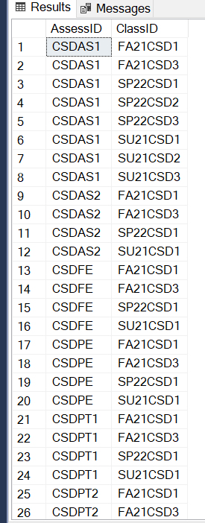

* **SELECT * FROM Grade**

INSERT Grade(SID, AssessID, Score, [Date]) VALUES ('HE160001', 'CSDAS1', 7, CAST('2022-07-26' AS date));

INSERT Grade(SID, AssessID, Score, [Date]) VALUES ('HE160001', 'CSDAS2', 6.5, CAST('2022-07-26' AS date));

INSERT Grade(SID, AssessID, Score, [Date]) VALUES ('HE160001', 'CSDPT1', 8, CAST('2022-07-26' AS date));

INSERT Grade(SID, AssessID, Score, [Date]) VALUES ('HE160001', 'CSDPT2', 6, CAST('2022-07-26' AS date));

INSERT Grade(SID, AssessID, Score, [Date]) VALUES ('HE160001', 'CSDPE', 9, CAST('2022-07-26' AS date));

INSERT Grade(SID, AssessID, Score, [Date]) VALUES ('HE160001', 'CSDFE', 7.6, CAST('2022-07-26' AS date));

INSERT Grade(SID, AssessID, Score, [Date]) VALUES ('HE160001', 'DBIAS1', 5.6, CAST('2022-07-26' AS date));

INSERT Grade(SID, AssessID, Score, [Date]) VALUES ('HE160001', 'DBIAS2', 8.6, CAST('2022-07-26' AS date));

INSERT Grade(SID, AssessID, Score, [Date]) VALUES ('HE160001', 'DBIPT1', 7.6, CAST('2022-07-26' AS date));

INSERT Grade(SID, AssessID, Score, [Date]) VALUES ('HE160001', 'DBIPT2', 7.5, CAST('2022-07-26' AS date));

INSERT Grade(SID, AssessID, Score, [Date]) VALUES ('HE160001', 'DBIPE', 8.2, CAST('2022-07-26' AS date));

INSERT Grade(SID, AssessID, Score, [Date]) VALUES ('HE160001', 'DBIFE', 3.5, CAST('2022-07-26' AS date));

INSERT Grade(SID, AssessID, Score, [Date]) VALUES ('HE160001', 'JPDAS1', 6.5, CAST('2022-07-26' AS date));

INSERT Grade(SID, AssessID, Score, [Date]) VALUES ('HE160001', 'JPDAS2', 8, CAST('2022-07-26' AS date));

INSERT Grade(SID, AssessID, Score, [Date]) VALUES ('HE160001', 'JPDPT1', 8.7, CAST('2022-07-26' AS date));

INSERT Grade(SID, AssessID, Score, [Date]) VALUES ('HE160001', 'JPDPT2', 7.2, CAST('2022-07-26' AS date));

INSERT Grade(SID, AssessID, Score, [Date]) VALUES ('HE160001', 'JPDFE', 7.3, CAST('2022-07-26' AS date));

INSERT Grade(SID, AssessID, Score, [Date]) VALUES ('HE160001', 'LABLOC', 753, CAST('2022-07-26' AS date));

INSERT Grade(SID, AssessID, Score, [Date]) VALUES ('HE160001', 'IAOLAB1', 10, CAST('2022-07-26' AS date));

INSERT Grade(SID, AssessID, Score, [Date]) VALUES ('HE160001', 'IAOLAB2', 9.5, CAST('2022-07-26' AS date));

INSERT Grade(SID, AssessID, Score, [Date]) VALUES ('HE160001', 'IAOLAB3', 8, CAST('2022-07-26' AS date));

INSERT Grade(SID, AssessID, Score, [Date]) VALUES ('HE160001', 'IAOLAB4', 10, CAST('2022-07-26' AS date));

INSERT Grade(SID, AssessID, Score, [Date]) VALUES ('HE160001', 'IAOLAB5', 10, CAST('2022-07-26' AS date));

INSERT Grade(SID, AssessID, Score, [Date]) VALUES ('HE160001', 'IAOLAB6', 10, CAST('2022-07-26' AS date));

INSERT Grade(SID, AssessID, Score, [Date]) VALUES ('HE160001', 'IAOLAB7', 10, CAST('2022-07-26' AS date));

INSERT Grade(SID, AssessID, Score, [Date]) VALUES ('HE160001', 'IAOLAB8', 9.5, CAST('2022-07-26' AS date));

INSERT Grade(SID, AssessID, Score, [Date]) VALUES ('HE160001', 'IAOLAB9', 8, CAST('2022-07-26' AS date));

INSERT Grade(SID, AssessID, Score, [Date]) VALUES ('HE160001', 'IAOLAB10', 9, CAST('2022-07-26' AS date));

INSERT Grade(SID, AssessID, Score, [Date]) VALUES ('HE160001', 'IAOPT1', 8.5, CAST('2022-07-26' AS date));

INSERT Grade(SID, AssessID, Score, [Date]) VALUES ('HE160001', 'IAOPT2', 9.5, CAST('2022-07-26' AS date));

INSERT Grade(SID, AssessID, Score, [Date]) VALUES ('HE160001', 'IAOFE', 7, CAST('2022-07-26' AS date));

INSERT Grade(SID, AssessID, Score, [Date]) VALUES ('HE160002', 'CSDAS1', 8, CAST('2022-07-26' AS date));

INSERT Grade(SID, AssessID, Score, [Date]) VALUES ('HE160002', 'CSDAS2', 6.5, CAST('2022-07-26' AS date));

INSERT Grade(SID, AssessID, Score, [Date]) VALUES ('HE160002', 'CSDPT1', 9, CAST('2022-07-26' AS date));

INSERT Grade(SID, AssessID, Score, [Date]) VALUES ('HE160002', 'CSDPT2', 7, CAST('2022-07-26' AS date));

INSERT Grade(SID, AssessID, Score, [Date]) VALUES ('HE160002', 'CSDPE', 9.2, CAST('2022-07-26' AS date));

INSERT Grade(SID, AssessID, Score, [Date]) VALUES ('HE160002', 'CSDFE', 7.3, CAST('2022-07-26' AS date));

INSERT Grade(SID, AssessID, Score, [Date]) VALUES ('HE160002', 'DBIAS1', 4.6, CAST('2022-07-26' AS date));

INSERT Grade(SID, AssessID, Score, [Date]) VALUES ('HE160002', 'DBIAS2', 5.6, CAST('2022-07-26' AS date));

INSERT Grade(SID, AssessID, Score, [Date]) VALUES ('HE160002', 'DBIPT1', 7.9, CAST('2022-07-26' AS date));

INSERT Grade(SID, AssessID, Score, [Date]) VALUES ('HE160002', 'DBIPT2', 7.8, CAST('2022-07-26' AS date));

INSERT Grade(SID, AssessID, Score, [Date]) VALUES ('HE160002', 'DBIPE', 7.2, CAST('2022-07-26' AS date));

INSERT Grade(SID, AssessID, Score, [Date]) VALUES ('HE160002', 'DBIFE', 7.5, CAST('2022-07-26' AS date));

INSERT Grade(SID, AssessID, Score, [Date]) VALUES ('HE160002', 'JPDAS1', 6.8, CAST('2022-07-26' AS date));

INSERT Grade(SID, AssessID, Score, [Date]) VALUES ('HE160002', 'JPDAS2', 6, CAST('2022-07-26' AS date));

INSERT Grade(SID, AssessID, Score, [Date]) VALUES ('HE160002', 'JPDPT1', 9, CAST('2022-07-26' AS date));

INSERT Grade(SID, AssessID, Score, [Date]) VALUES ('HE160002', 'JPDPT2', 8, CAST('2022-07-26' AS date));

INSERT Grade(SID, AssessID, Score, [Date]) VALUES ('HE160002', 'JPDFE', 7.3, CAST('2022-07-26' AS date));

INSERT Grade(SID, AssessID, Score, [Date]) VALUES ('HE160002', 'LABLOC', 751, CAST('2022-07-26' AS date));

INSERT Grade(SID, AssessID, Score, [Date]) VALUES ('HE160002', 'IAOLAB1', 10, CAST('2022-07-26' AS date));

INSERT Grade(SID, AssessID, Score, [Date]) VALUES ('HE160002', 'IAOLAB2', 10, CAST('2022-07-26' AS date));

INSERT Grade(SID, AssessID, Score, [Date]) VALUES ('HE160002', 'IAOLAB3', 9, CAST('2022-07-26' AS date));

INSERT Grade(SID, AssessID, Score, [Date]) VALUES ('HE160002', 'IAOLAB4', 9, CAST('2022-07-26' AS date));

INSERT Grade(SID, AssessID, Score, [Date]) VALUES ('HE160002', 'IAOLAB5', 10, CAST('2022-07-26' AS date));

INSERT Grade(SID, AssessID, Score, [Date]) VALUES ('HE160002', 'IAOLAB6', 10, CAST('2022-07-26' AS date));

INSERT Grade(SID, AssessID, Score, [Date]) VALUES ('HE160002', 'IAOLAB7', 10, CAST('2022-07-26' AS date));

INSERT Grade(SID, AssessID, Score, [Date]) VALUES ('HE160002', 'IAOLAB8', 9.5, CAST('2022-07-26' AS date));

INSERT Grade(SID, AssessID, Score, [Date]) VALUES ('HE160002', 'IAOLAB9', 9, CAST('2022-07-26' AS date));

INSERT Grade(SID, AssessID, Score, [Date]) VALUES ('HE160002', 'IAOLAB10', 8, CAST('2022-07-26' AS date));

INSERT Grade(SID, AssessID, Score, [Date]) VALUES ('HE160002', 'IAOPT1', 8.5, CAST('2022-07-26' AS date));

INSERT Grade(SID, AssessID, Score, [Date]) VALUES ('HE160002', 'IAOPT2', 8, CAST('2022-07-26' AS date));

INSERT Grade(SID, AssessID, Score, [Date]) VALUES ('HE160002', 'IAOFE', 8, CAST('2022-07-26' AS date));

INSERT Grade(SID, AssessID, Score, [Date]) VALUES ('HE160003', 'CSDAS1', 9, CAST('2022-07-26' AS date));

INSERT Grade(SID, AssessID, Score, [Date]) VALUES ('HE160003', 'CSDAS2', 8.5, CAST('2022-07-26' AS date));

INSERT Grade(SID, AssessID, Score, [Date]) VALUES ('HE160003', 'CSDPT1', 9, CAST('2022-07-26' AS date));

INSERT Grade(SID, AssessID, Score, [Date]) VALUES ('HE160003', 'CSDPT2', 6, CAST('2022-07-26' AS date));

INSERT Grade(SID, AssessID, Score, [Date]) VALUES ('HE160003', 'CSDPE', 5, CAST('2022-07-26' AS date));

INSERT Grade(SID, AssessID, Score, [Date]) VALUES ('HE160003', 'CSDFE', 7.8, CAST('2022-07-26' AS date));

INSERT Grade(SID, AssessID, Score, [Date]) VALUES ('HE160003', 'DBIAS1', 6, CAST('2022-07-26' AS date));

INSERT Grade(SID, AssessID, Score, [Date]) VALUES ('HE160003', 'DBIAS2', 8.2, CAST('2022-07-26' AS date));

INSERT Grade(SID, AssessID, Score, [Date]) VALUES ('HE160003', 'DBIPT1', 7.4, CAST('2022-07-26' AS date));

INSERT Grade(SID, AssessID, Score, [Date]) VALUES ('HE160003', 'DBIPT2', 6.5, CAST('2022-07-26' AS date));

INSERT Grade(SID, AssessID, Score, [Date]) VALUES ('HE160003', 'DBIPE', 8.7, CAST('2022-07-26' AS date));

INSERT Grade(SID, AssessID, Score, [Date]) VALUES ('HE160003', 'DBIFE', 6.5, CAST('2022-07-26' AS date));

INSERT Grade(SID, AssessID, Score, [Date]) VALUES ('HE160003', 'JPDAS1', 7.5, CAST('2022-07-26' AS date));

INSERT Grade(SID, AssessID, Score, [Date]) VALUES ('HE160003', 'JPDAS2', 8, CAST('2022-07-26' AS date));

INSERT Grade(SID, AssessID, Score, [Date]) VALUES ('HE160003', 'JPDPT1', 8.7, CAST('2022-07-26' AS date));

INSERT Grade(SID, AssessID, Score, [Date]) VALUES ('HE160003', 'JPDPT2', 7.6, CAST('2022-07-26' AS date));

INSERT Grade(SID, AssessID, Score, [Date]) VALUES ('HE160003', 'JPDFE', 6, CAST('2022-07-26' AS date));

INSERT Grade(SID, AssessID, Score, [Date]) VALUES ('HE160003', 'LABLOC', 750, CAST('2022-07-26' AS date));

INSERT Grade(SID, AssessID, Score, [Date]) VALUES ('HE160003', 'IAOLAB1', 10, CAST('2022-07-26' AS date));

INSERT Grade(SID, AssessID, Score, [Date]) VALUES ('HE160003', 'IAOLAB2', 9.5, CAST('2022-07-26' AS date));

INSERT Grade(SID, AssessID, Score, [Date]) VALUES ('HE160003', 'IAOLAB3', 8, CAST('2022-07-26' AS date));

INSERT Grade(SID, AssessID, Score, [Date]) VALUES ('HE160003', 'IAOLAB4', 9, CAST('2022-07-26' AS date));

INSERT Grade(SID, AssessID, Score, [Date]) VALUES ('HE160003', 'IAOLAB5', 10, CAST('2022-07-26' AS date));

INSERT Grade(SID, AssessID, Score, [Date]) VALUES ('HE160003', 'IAOLAB6', 10, CAST('2022-07-26' AS date));

INSERT Grade(SID, AssessID, Score, [Date]) VALUES ('HE160003', 'IAOLAB7', 7, CAST('2022-07-26' AS date));

INSERT Grade(SID, AssessID, Score, [Date]) VALUES ('HE160003', 'IAOLAB8', 9.5, CAST('2022-07-26' AS date));

INSERT Grade(SID, AssessID, Score, [Date]) VALUES ('HE160003', 'IAOLAB9', 3, CAST('2022-07-26' AS date));

INSERT Grade(SID, AssessID, Score, [Date]) VALUES ('HE160003', 'IAOLAB10', 9, CAST('2022-07-26' AS date));

INSERT Grade(SID, AssessID, Score, [Date]) VALUES ('HE160003', 'IAOPT1', 8.5, CAST('2022-07-26' AS date));

INSERT Grade(SID, AssessID, Score, [Date]) VALUES ('HE160003', 'IAOPT2', 9.5, CAST('2022-07-26' AS date));

INSERT Grade(SID, AssessID, Score, [Date]) VALUES ('HE160003', 'IAOFE', 4, CAST('2022-07-26' AS date));

INSERT Grade(SID, AssessID, Score, [Date]) VALUES ('HE160004', 'CSDAS1', 9, CAST('2022-07-26' AS date));

INSERT Grade(SID, AssessID, Score, [Date]) VALUES ('HE160004', 'CSDAS2', 7.5, CAST('2022-07-26' AS date));

INSERT Grade(SID, AssessID, Score, [Date]) VALUES ('HE160004', 'CSDPT1', 8, CAST('2022-07-26' AS date));

INSERT Grade(SID, AssessID, Score, [Date]) VALUES ('HE160004', 'CSDPT2', 6, CAST('2022-07-26' AS date));

INSERT Grade(SID, AssessID, Score, [Date]) VALUES ('HE160004', 'CSDPE', 9, CAST('2022-07-26' AS date));

INSERT Grade(SID, AssessID, Score, [Date]) VALUES ('HE160004', 'CSDFE', 7.7, CAST('2022-07-26' AS date));

INSERT Grade(SID, AssessID, Score, [Date]) VALUES ('HE160004', 'DBIAS1', 5.6, CAST('2022-07-26' AS date));

INSERT Grade(SID, AssessID, Score, [Date]) VALUES ('HE160004', 'DBIAS2', 8.6, CAST('2022-07-26' AS date));

INSERT Grade(SID, AssessID, Score, [Date]) VALUES ('HE160004', 'DBIPT1', 6.6, CAST('2022-07-26' AS date));

INSERT Grade(SID, AssessID, Score, [Date]) VALUES ('HE160004', 'DBIPT2', 7.5, CAST('2022-07-26' AS date));

INSERT Grade(SID, AssessID, Score, [Date]) VALUES ('HE160004', 'DBIPE', 8.6, CAST('2022-07-26' AS date));

INSERT Grade(SID, AssessID, Score, [Date]) VALUES ('HE160004', 'DBIFE', 6.5, CAST('2022-07-26' AS date));

INSERT Grade(SID, AssessID, Score, [Date]) VALUES ('HE160004', 'JPDAS1', 6.5, CAST('2022-07-26' AS date));

INSERT Grade(SID, AssessID, Score, [Date]) VALUES ('HE160004', 'JPDAS2', 8, CAST('2022-07-26' AS date));

INSERT Grade(SID, AssessID, Score, [Date]) VALUES ('HE160004', 'JPDPT1', 7.7, CAST('2022-07-26' AS date));

INSERT Grade(SID, AssessID, Score, [Date]) VALUES ('HE160004', 'JPDPT2', 8.2, CAST('2022-07-26' AS date));

INSERT Grade(SID, AssessID, Score, [Date]) VALUES ('HE160004', 'JPDFE', 9.3, CAST('2022-07-26' AS date));

INSERT Grade(SID, AssessID, Score, [Date]) VALUES ('HE160004', 'LABLOC', 780, CAST('2022-07-26' AS date));

INSERT Grade(SID, AssessID, Score, [Date]) VALUES ('HE160004', 'IAOLAB1', 9, CAST('2022-07-26' AS date));

INSERT Grade(SID, AssessID, Score, [Date]) VALUES ('HE160004', 'IAOLAB2', 9.5, CAST('2022-07-26' AS date));

INSERT Grade(SID, AssessID, Score, [Date]) VALUES ('HE160004', 'IAOLAB3', 8, CAST('2022-07-26' AS date));

INSERT Grade(SID, AssessID, Score, [Date]) VALUES ('HE160004', 'IAOLAB4', 7, CAST('2022-07-26' AS date));

INSERT Grade(SID, AssessID, Score, [Date]) VALUES ('HE160004', 'IAOLAB5', 10, CAST('2022-07-26' AS date));

INSERT Grade(SID, AssessID, Score, [Date]) VALUES ('HE160004', 'IAOLAB6', 7, CAST('2022-07-26' AS date));

INSERT Grade(SID, AssessID, Score, [Date]) VALUES ('HE160004', 'IAOLAB7', 10, CAST('2022-07-26' AS date));

INSERT Grade(SID, AssessID, Score, [Date]) VALUES ('HE160004', 'IAOLAB8', 9.5, CAST('2022-07-26' AS date));

INSERT Grade(SID, AssessID, Score, [Date]) VALUES ('HE160004', 'IAOLAB9', 8, CAST('2022-07-26' AS date));

INSERT Grade(SID, AssessID, Score, [Date]) VALUES ('HE160004', 'IAOLAB10', 9, CAST('2022-07-26' AS date));

INSERT Grade(SID, AssessID, Score, [Date]) VALUES ('HE160004', 'IAOPT1', 7, CAST('2022-07-26' AS date));

INSERT Grade(SID, AssessID, Score, [Date]) VALUES ('HE160004', 'IAOPT2', 8, CAST('2022-07-26' AS date));

INSERT Grade(SID, AssessID, Score, [Date]) VALUES ('HE160004', 'IAOFE', 8, CAST('2022-07-26' AS date));

INSERT Grade(SID, AssessID, Score, [Date]) VALUES ('HE160005', 'CSDAS1', 3, CAST('2022-07-26' AS date));

INSERT Grade(SID, AssessID, Score, [Date]) VALUES ('HE160005', 'CSDAS2', 6.5, CAST('2022-07-26' AS date));

INSERT Grade(SID, AssessID, Score, [Date]) VALUES ('HE160005', 'CSDPT1', 4, CAST('2022-07-26' AS date));

INSERT Grade(SID, AssessID, Score, [Date]) VALUES ('HE160005', 'CSDPT2', 6, CAST('2022-07-26' AS date));

INSERT Grade(SID, AssessID, Score, [Date]) VALUES ('HE160005', 'CSDPE', 7, CAST('2022-07-26' AS date));

INSERT Grade(SID, AssessID, Score, [Date]) VALUES ('HE160005', 'CSDFE', 7.5, CAST('2022-07-26' AS date));

INSERT Grade(SID, AssessID, Score, [Date]) VALUES ('HE160005', 'DBIAS1', 5.4, CAST('2022-07-26' AS date));

INSERT Grade(SID, AssessID, Score, [Date]) VALUES ('HE160005', 'DBIAS2', 8.6, CAST('2022-07-26' AS date));

INSERT Grade(SID, AssessID, Score, [Date]) VALUES ('HE160005', 'DBIPT1', 7.5, CAST('2022-07-26' AS date));

INSERT Grade(SID, AssessID, Score, [Date]) VALUES ('HE160005', 'DBIPT2', 7.5, CAST('2022-07-26' AS date));

INSERT Grade(SID, AssessID, Score, [Date]) VALUES ('HE160005', 'DBIPE', 4.2, CAST('2022-07-26' AS date));

INSERT Grade(SID, AssessID, Score, [Date]) VALUES ('HE160005', 'DBIFE', 3.8, CAST('2022-07-26' AS date));

INSERT Grade(SID, AssessID, Score, [Date]) VALUES ('HE160005', 'JPDAS1', 6.5, CAST('2022-07-26' AS date));

INSERT Grade(SID, AssessID, Score, [Date]) VALUES ('HE160005', 'JPDAS2', 6, CAST('2022-07-26' AS date));

INSERT Grade(SID, AssessID, Score, [Date]) VALUES ('HE160005', 'JPDPT1', 8.7, CAST('2022-07-26' AS date));

INSERT Grade(SID, AssessID, Score, [Date]) VALUES ('HE160005', 'JPDPT2', 7.2, CAST('2022-07-26' AS date));

INSERT Grade(SID, AssessID, Score, [Date]) VALUES ('HE160005', 'JPDFE', 7.3, CAST('2022-07-26' AS date));

INSERT Grade(SID, AssessID, Score, [Date]) VALUES ('HE160005', 'LABLOC', 733, CAST('2022-07-26' AS date));

INSERT Grade(SID, AssessID, Score, [Date]) VALUES ('HE160005', 'IAOLAB1', 10, CAST('2022-07-26' AS date));

INSERT Grade(SID, AssessID, Score, [Date]) VALUES ('HE160005', 'IAOLAB2', 9.5, CAST('2022-07-26' AS date));

INSERT Grade(SID, AssessID, Score, [Date]) VALUES ('HE160005', 'IAOLAB3', 8, CAST('2022-07-26' AS date));

INSERT Grade(SID, AssessID, Score, [Date]) VALUES ('HE160005', 'IAOLAB4', 10, CAST('2022-07-26' AS date));

INSERT Grade(SID, AssessID, Score, [Date]) VALUES ('HE160005', 'IAOLAB5', 8.5, CAST('2022-07-26' AS date));

INSERT Grade(SID, AssessID, Score, [Date]) VALUES ('HE160005', 'IAOLAB6', 10, CAST('2022-07-26' AS date));

INSERT Grade(SID, AssessID, Score, [Date]) VALUES ('HE160005', 'IAOLAB7', 10, CAST('2022-07-26' AS date));

INSERT Grade(SID, AssessID, Score, [Date]) VALUES ('HE160005', 'IAOLAB8', 9.5, CAST('2022-07-26' AS date));

INSERT Grade(SID, AssessID, Score, [Date]) VALUES ('HE160005', 'IAOLAB9', 8, CAST('2022-07-26' AS date));

INSERT Grade(SID, AssessID, Score, [Date]) VALUES ('HE160005', 'IAOLAB10', 10, CAST('2022-07-26' AS date));

INSERT Grade(SID, AssessID, Score, [Date]) VALUES ('HE160005', 'IAOPT1', 9, CAST('2022-07-26' AS date));

INSERT Grade(SID, AssessID, Score, [Date]) VALUES ('HE160005', 'IAOPT2', 8, CAST('2022-07-26' AS date));

INSERT Grade(SID, AssessID, Score, [Date]) VALUES ('HE160005', 'IAOFE', 7, CAST('2022-07-26' AS date));

INSERT Grade(SID, AssessID, Score, [Date]) VALUES ('HE160006', 'CSDAS1', 6, CAST('2022-07-26' AS date));

INSERT Grade(SID, AssessID, Score, [Date]) VALUES ('HE160006', 'CSDAS2', 8, CAST('2022-07-26' AS date));

INSERT Grade(SID, AssessID, Score, [Date]) VALUES ('HE160006', 'CSDPT1', 9, CAST('2022-07-26' AS date));

INSERT Grade(SID, AssessID, Score, [Date]) VALUES ('HE160006', 'CSDPT2', 6.6, CAST('2022-07-26' AS date));

INSERT Grade(SID, AssessID, Score, [Date]) VALUES ('HE160006', 'CSDPE', 9.5, CAST('2022-07-26' AS date));

INSERT Grade(SID, AssessID, Score, [Date]) VALUES ('HE160006', 'CSDFE', 7.6, CAST('2022-07-26' AS date));

INSERT Grade(SID, AssessID, Score, [Date]) VALUES ('HE160006', 'DBIAS1', 5.4, CAST('2022-07-26' AS date));

INSERT Grade(SID, AssessID, Score, [Date]) VALUES ('HE160006', 'DBIAS2', 6.6, CAST('2022-07-26' AS date));

INSERT Grade(SID, AssessID, Score, [Date]) VALUES ('HE160006', 'DBIPT1', 7.3, CAST('2022-07-26' AS date));

INSERT Grade(SID, AssessID, Score, [Date]) VALUES ('HE160006', 'DBIPT2', 7.5, CAST('2022-07-26' AS date));

INSERT Grade(SID, AssessID, Score, [Date]) VALUES ('HE160006', 'DBIPE', 4.2, CAST('2022-07-26' AS date));

INSERT Grade(SID, AssessID, Score, [Date]) VALUES ('HE160006', 'DBIFE', 7.5, CAST('2022-07-26' AS date));

INSERT Grade(SID, AssessID, Score, [Date]) VALUES ('HE160006', 'JPDAS1', 6.8, CAST('2022-07-26' AS date));

INSERT Grade(SID, AssessID, Score, [Date]) VALUES ('HE160006', 'JPDAS2', 5, CAST('2022-07-26' AS date));

INSERT Grade(SID, AssessID, Score, [Date]) VALUES ('HE160006', 'JPDPT1', 8.7, CAST('2022-07-26' AS date));

INSERT Grade(SID, AssessID, Score, [Date]) VALUES ('HE160006', 'JPDPT2', 7.2, CAST('2022-07-26' AS date));

INSERT Grade(SID, AssessID, Score, [Date]) VALUES ('HE160006', 'JPDFE', 7.6, CAST('2022-07-26' AS date));

INSERT Grade(SID, AssessID, Score, [Date]) VALUES ('HE160006', 'LABLOC', 749, CAST('2022-07-26' AS date));

INSERT Grade(SID, AssessID, Score, [Date]) VALUES ('HE160006', 'IAOLAB1', 10, CAST('2022-07-26' AS date));

INSERT Grade(SID, AssessID, Score, [Date]) VALUES ('HE160006', 'IAOLAB2', 9.5, CAST('2022-07-26' AS date));

INSERT Grade(SID, AssessID, Score, [Date]) VALUES ('HE160006', 'IAOLAB3', 8.5, CAST('2022-07-26' AS date));

INSERT Grade(SID, AssessID, Score, [Date]) VALUES ('HE160006', 'IAOLAB4', 9, CAST('2022-07-26' AS date));

INSERT Grade(SID, AssessID, Score, [Date]) VALUES ('HE160006', 'IAOLAB5', 10, CAST('2022-07-26' AS date));

INSERT Grade(SID, AssessID, Score, [Date]) VALUES ('HE160006', 'IAOLAB6', 8, CAST('2022-07-26' AS date));

INSERT Grade(SID, AssessID, Score, [Date]) VALUES ('HE160006', 'IAOLAB7', 4, CAST('2022-07-26' AS date));

INSERT Grade(SID, AssessID, Score, [Date]) VALUES ('HE160006', 'IAOLAB8', 9.5, CAST('2022-07-26' AS date));

INSERT Grade(SID, AssessID, Score, [Date]) VALUES ('HE160006', 'IAOLAB9', 8, CAST('2022-07-26' AS date));

INSERT Grade(SID, AssessID, Score, [Date]) VALUES ('HE160006', 'IAOLAB10', 4, CAST('2022-07-26' AS date));

INSERT Grade(SID, AssessID, Score, [Date]) VALUES ('HE160006', 'IAOPT1', 8.5, CAST('2022-07-26' AS date));

INSERT Grade(SID, AssessID, Score, [Date]) VALUES ('HE160006', 'IAOPT2', 9.5, CAST('2022-07-26' AS date));

INSERT Grade(SID, AssessID, Score, [Date]) VALUES ('HE160006', 'IAOFE', 3, CAST('2022-07-26' AS date));

INSERT Grade(SID, AssessID, Score, [Date]) VALUES ('HE160007', 'CSDAS1', 9, CAST('2022-07-26' AS date));

INSERT Grade(SID, AssessID, Score, [Date]) VALUES ('HE160007', 'CSDAS2', 8.5, CAST('2022-07-26' AS date));

INSERT Grade(SID, AssessID, Score, [Date]) VALUES ('HE160007', 'CSDPT1', 7, CAST('2022-07-26' AS date));

INSERT Grade(SID, AssessID, Score, [Date]) VALUES ('HE160007', 'CSDPT2', 9, CAST('2022-07-26' AS date));

INSERT Grade(SID, AssessID, Score, [Date]) VALUES ('HE160007', 'CSDPE', 9.5, CAST('2022-07-26' AS date));

INSERT Grade(SID, AssessID, Score, [Date]) VALUES ('HE160007', 'CSDFE', 8.6, CAST('2022-07-26' AS date));

INSERT Grade(SID, AssessID, Score, [Date]) VALUES ('HE160007', 'DBIAS1', 8.6, CAST('2022-07-26' AS date));

INSERT Grade(SID, AssessID, Score, [Date]) VALUES ('HE160007', 'DBIAS2', 6.6, CAST('2022-07-26' AS date));

INSERT Grade(SID, AssessID, Score, [Date]) VALUES ('HE160007', 'DBIPT1', 8.6, CAST('2022-07-26' AS date));

INSERT Grade(SID, AssessID, Score, [Date]) VALUES ('HE160007', 'DBIPT2', 7.7, CAST('2022-07-26' AS date));

INSERT Grade(SID, AssessID, Score, [Date]) VALUES ('HE160007', 'DBIPE', 8.8, CAST('2022-07-26' AS date));

INSERT Grade(SID, AssessID, Score, [Date]) VALUES ('HE160007', 'DBIFE', 8.5, CAST('2022-07-26' AS date));

INSERT Grade(SID, AssessID, Score, [Date]) VALUES ('HE160007', 'JPDAS1', 9.5, CAST('2022-07-26' AS date));

INSERT Grade(SID, AssessID, Score, [Date]) VALUES ('HE160007', 'JPDAS2', 8, CAST('2022-07-26' AS date));

INSERT Grade(SID, AssessID, Score, [Date]) VALUES ('HE160007', 'JPDPT1', 8.7, CAST('2022-07-26' AS date));

INSERT Grade(SID, AssessID, Score, [Date]) VALUES ('HE160007', 'JPDPT2', 7.2, CAST('2022-07-26' AS date));

INSERT Grade(SID, AssessID, Score, [Date]) VALUES ('HE160007', 'JPDFE', 7.3, CAST('2022-07-26' AS date));

INSERT Grade(SID, AssessID, Score, [Date]) VALUES ('HE160007', 'LABLOC', 786, CAST('2022-07-26' AS date));

INSERT Grade(SID, AssessID, Score, [Date]) VALUES ('HE160007', 'IAOLAB1', 9, CAST('2022-07-26' AS date));

INSERT Grade(SID, AssessID, Score, [Date]) VALUES ('HE160007', 'IAOLAB2', 9.5, CAST('2022-07-26' AS date));

INSERT Grade(SID, AssessID, Score, [Date]) VALUES ('HE160007', 'IAOLAB3', 8, CAST('2022-07-26' AS date));

INSERT Grade(SID, AssessID, Score, [Date]) VALUES ('HE160007', 'IAOLAB4', 9, CAST('2022-07-26' AS date));

INSERT Grade(SID, AssessID, Score, [Date]) VALUES ('HE160007', 'IAOLAB5', 10, CAST('2022-07-26' AS date));

INSERT Grade(SID, AssessID, Score, [Date]) VALUES ('HE160007', 'IAOLAB6', 10, CAST('2022-07-26' AS date));

INSERT Grade(SID, AssessID, Score, [Date]) VALUES ('HE160007', 'IAOLAB7', 10, CAST('2022-07-26' AS date));

INSERT Grade(SID, AssessID, Score, [Date]) VALUES ('HE160007', 'IAOLAB8', 9.5, CAST('2022-07-26' AS date));

INSERT Grade(SID, AssessID, Score, [Date]) VALUES ('HE160007', 'IAOLAB9', 8, CAST('2022-07-26' AS date));

INSERT Grade(SID, AssessID, Score, [Date]) VALUES ('HE160007', 'IAOLAB10', 10, CAST('2022-07-26' AS date));

INSERT Grade(SID, AssessID, Score, [Date]) VALUES ('HE160007', 'IAOPT1', 8.5, CAST('2022-07-26' AS date));

INSERT Grade(SID, AssessID, Score, [Date]) VALUES ('HE160007', 'IAOPT2', 9.5, CAST('2022-07-26' AS date));

INSERT Grade(SID, AssessID, Score, [Date]) VALUES ('HE160007', 'IAOFE', 8, CAST('2022-07-26' AS date));

INSERT Grade(SID, AssessID, Score, [Date]) VALUES ('HE160008', 'CSDAS1', 4, CAST('2022-07-26' AS date));

INSERT Grade(SID, AssessID, Score, [Date]) VALUES ('HE160008', 'CSDAS2', 4.5, CAST('2022-07-26' AS date));

INSERT Grade(SID, AssessID, Score, [Date]) VALUES ('HE160008', 'CSDPT1', 5, CAST('2022-07-26' AS date));

INSERT Grade(SID, AssessID, Score, [Date]) VALUES ('HE160008', 'CSDPT2', 7, CAST('2022-07-26' AS date));

INSERT Grade(SID, AssessID, Score, [Date]) VALUES ('HE160008', 'CSDPE', 5, CAST('2022-07-26' AS date));

INSERT Grade(SID, AssessID, Score, [Date]) VALUES ('HE160008', 'CSDFE', 7.8, CAST('2022-07-26' AS date));

INSERT Grade(SID, AssessID, Score, [Date]) VALUES ('HE160008', 'DBIAS1', 8.6, CAST('2022-07-26' AS date));

INSERT Grade(SID, AssessID, Score, [Date]) VALUES ('HE160008', 'DBIAS2', 8.6, CAST('2022-07-26' AS date));

INSERT Grade(SID, AssessID, Score, [Date]) VALUES ('HE160008', 'DBIPT1', 7.6, CAST('2022-07-26' AS date));

INSERT Grade(SID, AssessID, Score, [Date]) VALUES ('HE160008', 'DBIPT2', 7.9, CAST('2022-07-26' AS date));

INSERT Grade(SID, AssessID, Score, [Date]) VALUES ('HE160008', 'DBIPE', 8.2, CAST('2022-07-26' AS date));

INSERT Grade(SID, AssessID, Score, [Date]) VALUES ('HE160008', 'DBIFE', 4.5, CAST('2022-07-26' AS date));

INSERT Grade(SID, AssessID, Score, [Date]) VALUES ('HE160008', 'JPDAS1', 6.5, CAST('2022-07-26' AS date));

INSERT Grade(SID, AssessID, Score, [Date]) VALUES ('HE160008', 'JPDAS2', 8, CAST('2022-07-26' AS date));

INSERT Grade(SID, AssessID, Score, [Date]) VALUES ('HE160008', 'JPDPT1', 8.7, CAST('2022-07-26' AS date));

INSERT Grade(SID, AssessID, Score, [Date]) VALUES ('HE160008', 'JPDPT2', 7.4, CAST('2022-07-26' AS date));

INSERT Grade(SID, AssessID, Score, [Date]) VALUES ('HE160008', 'JPDFE', 7.3, CAST('2022-07-26' AS date));

INSERT Grade(SID, AssessID, Score, [Date]) VALUES ('HE160008', 'LABLOC', 540, CAST('2022-07-26' AS date));

INSERT Grade(SID, AssessID, Score, [Date]) VALUES ('HE160008', 'IAOLAB1', 10, CAST('2022-07-26' AS date));

INSERT Grade(SID, AssessID, Score, [Date]) VALUES ('HE160008', 'IAOLAB2', 9.5, CAST('2022-07-26' AS date));

INSERT Grade(SID, AssessID, Score, [Date]) VALUES ('HE160008', 'IAOLAB3', 8, CAST('2022-07-26' AS date));

INSERT Grade(SID, AssessID, Score, [Date]) VALUES ('HE160008', 'IAOLAB4', 10, CAST('2022-07-26' AS date));

INSERT Grade(SID, AssessID, Score, [Date]) VALUES ('HE160008', 'IAOLAB5', 0, CAST('2022-07-26' AS date));

INSERT Grade(SID, AssessID, Score, [Date]) VALUES ('HE160008', 'IAOLAB6', 10, CAST('2022-07-26' AS date));

INSERT Grade(SID, AssessID, Score, [Date]) VALUES ('HE160008', 'IAOLAB7', 0, CAST('2022-07-26' AS date));

INSERT Grade(SID, AssessID, Score, [Date]) VALUES ('HE160008', 'IAOLAB8', 9.5, CAST('2022-07-26' AS date));

INSERT Grade(SID, AssessID, Score, [Date]) VALUES ('HE160008', 'IAOLAB9', 8, CAST('2022-07-26' AS date));

INSERT Grade(SID, AssessID, Score, [Date]) VALUES ('HE160008', 'IAOLAB10', 8, CAST('2022-07-26' AS date));

INSERT Grade(SID, AssessID, Score, [Date]) VALUES ('HE160008', 'IAOPT1', 8.7, CAST('2022-07-26' AS date));

INSERT Grade(SID, AssessID, Score, [Date]) VALUES ('HE160008', 'IAOPT2', 9.5, CAST('2022-07-26' AS date));

INSERT Grade(SID, AssessID, Score, [Date]) VALUES ('HE160008', 'IAOFE', 3, CAST('2022-07-26' AS date));

INSERT Grade(SID, AssessID, Score, [Date]) VALUES ('HE160009', 'CSDAS1', 8, CAST('2022-07-26' AS date));

INSERT Grade(SID, AssessID, Score, [Date]) VALUES ('HE160009', 'CSDAS2', 8.5, CAST('2022-07-26' AS date));

INSERT Grade(SID, AssessID, Score, [Date]) VALUES ('HE160009', 'CSDPT1', 8, CAST('2022-07-26' AS date));

INSERT Grade(SID, AssessID, Score, [Date]) VALUES ('HE160009', 'CSDPT2', 7, CAST('2022-07-26' AS date));

INSERT Grade(SID, AssessID, Score, [Date]) VALUES ('HE160009', 'CSDPE', 8, CAST('2022-07-26' AS date));

INSERT Grade(SID, AssessID, Score, [Date]) VALUES ('HE160009', 'CSDFE', 7.6, CAST('2022-07-26' AS date));

INSERT Grade(SID, AssessID, Score, [Date]) VALUES ('HE160009', 'DBIAS1', 7.6, CAST('2022-07-26' AS date));

INSERT Grade(SID, AssessID, Score, [Date]) VALUES ('HE160009', 'DBIAS2', 8.6, CAST('2022-07-26' AS date));

INSERT Grade(SID, AssessID, Score, [Date]) VALUES ('HE160009', 'DBIPT1', 7.6, CAST('2022-07-26' AS date));

INSERT Grade(SID, AssessID, Score, [Date]) VALUES ('HE160009', 'DBIPT2', 7.5, CAST('2022-07-26' AS date));

INSERT Grade(SID, AssessID, Score, [Date]) VALUES ('HE160009', 'DBIPE', 8.2, CAST('2022-07-26' AS date));

INSERT Grade(SID, AssessID, Score, [Date]) VALUES ('HE160009', 'DBIFE', 7.5, CAST('2022-07-26' AS date));

INSERT Grade(SID, AssessID, Score, [Date]) VALUES ('HE160009', 'JPDAS1', 9.5, CAST('2022-07-26' AS date));

INSERT Grade(SID, AssessID, Score, [Date]) VALUES ('HE160009', 'JPDAS2', 8, CAST('2022-07-26' AS date));

INSERT Grade(SID, AssessID, Score, [Date]) VALUES ('HE160009', 'JPDPT1', 9.7, CAST('2022-07-26' AS date));

INSERT Grade(SID, AssessID, Score, [Date]) VALUES ('HE160009', 'JPDPT2', 7.2, CAST('2022-07-26' AS date));

INSERT Grade(SID, AssessID, Score, [Date]) VALUES ('HE160009', 'JPDFE', 9.3, CAST('2022-07-26' AS date));

INSERT Grade(SID, AssessID, Score, [Date]) VALUES ('HE160009', 'LABLOC', 793, CAST('2022-07-26' AS date));

INSERT Grade(SID, AssessID, Score, [Date]) VALUES ('HE160009', 'IAOLAB1', 10, CAST('2022-07-26' AS date));

INSERT Grade(SID, AssessID, Score, [Date]) VALUES ('HE160009', 'IAOLAB2', 9.5, CAST('2022-07-26' AS date));

INSERT Grade(SID, AssessID, Score, [Date]) VALUES ('HE160009', 'IAOLAB3', 9, CAST('2022-07-26' AS date));

INSERT Grade(SID, AssessID, Score, [Date]) VALUES ('HE160009', 'IAOLAB4', 9, CAST('2022-07-26' AS date));

INSERT Grade(SID, AssessID, Score, [Date]) VALUES ('HE160009', 'IAOLAB5', 10, CAST('2022-07-26' AS date));

INSERT Grade(SID, AssessID, Score, [Date]) VALUES ('HE160009', 'IAOLAB6', 8, CAST('2022-07-26' AS date));

INSERT Grade(SID, AssessID, Score, [Date]) VALUES ('HE160009', 'IAOLAB7', 10, CAST('2022-07-26' AS date));

INSERT Grade(SID, AssessID, Score, [Date]) VALUES ('HE160009', 'IAOLAB8', 9.5, CAST('2022-07-26' AS date));

INSERT Grade(SID, AssessID, Score, [Date]) VALUES ('HE160009', 'IAOLAB9', 8, CAST('2022-07-26' AS date));

INSERT Grade(SID, AssessID, Score, [Date]) VALUES ('HE160009', 'IAOLAB10', 9, CAST('2022-07-26' AS date));

INSERT Grade(SID, AssessID, Score, [Date]) VALUES ('HE160009', 'IAOPT1', 8.5, CAST('2022-07-26' AS date));

INSERT Grade(SID, AssessID, Score, [Date]) VALUES ('HE160009', 'IAOPT2', 9.5, CAST('2022-07-26' AS date));

INSERT Grade(SID, AssessID, Score, [Date]) VALUES ('HE160009', 'IAOFE', 9, CAST('2022-07-26' AS date));

INSERT Grade(SID, AssessID, Score, [Date]) VALUES ('HE160010', 'CSDAS1', 7, CAST('2022-07-26' AS date));

INSERT Grade(SID, AssessID, Score, [Date]) VALUES ('HE160010', 'CSDAS2', 6.5, CAST('2022-07-26' AS date));

INSERT Grade(SID, AssessID, Score, [Date]) VALUES ('HE160010', 'CSDPT1', 8, CAST('2022-07-26' AS date));

INSERT Grade(SID, AssessID, Score, [Date]) VALUES ('HE160010', 'CSDPT2', 6, CAST('2022-07-26' AS date));

INSERT Grade(SID, AssessID, Score, [Date]) VALUES ('HE160010', 'CSDPE', 9, CAST('2022-07-26' AS date));

INSERT Grade(SID, AssessID, Score, [Date]) VALUES ('HE160010', 'CSDFE', 7.4, CAST('2022-07-26' AS date));

INSERT Grade(SID, AssessID, Score, [Date]) VALUES ('HE160010', 'DBIAS1', 5.6, CAST('2022-07-26' AS date));

INSERT Grade(SID, AssessID, Score, [Date]) VALUES ('HE160010', 'DBIAS2', 8.6, CAST('2022-07-26' AS date));

INSERT Grade(SID, AssessID, Score, [Date]) VALUES ('HE160010', 'DBIPT1', 7.3, CAST('2022-07-26' AS date));

INSERT Grade(SID, AssessID, Score, [Date]) VALUES ('HE160010', 'DBIPT2', 7.5, CAST('2022-07-26' AS date));

INSERT Grade(SID, AssessID, Score, [Date]) VALUES ('HE160010', 'DBIPE', 8.3, CAST('2022-07-26' AS date));

INSERT Grade(SID, AssessID, Score, [Date]) VALUES ('HE160010', 'DBIFE', 8.5, CAST('2022-07-26' AS date));

INSERT Grade(SID, AssessID, Score, [Date]) VALUES ('HE160010', 'JPDAS1', 6.3, CAST('2022-07-26' AS date));

INSERT Grade(SID, AssessID, Score, [Date]) VALUES ('HE160010', 'JPDAS2', 8, CAST('2022-07-26' AS date));

INSERT Grade(SID, AssessID, Score, [Date]) VALUES ('HE160010', 'JPDPT1', 8.7, CAST('2022-07-26' AS date));

INSERT Grade(SID, AssessID, Score, [Date]) VALUES ('HE160010', 'JPDPT2', 7.2, CAST('2022-07-26' AS date));

INSERT Grade(SID, AssessID, Score, [Date]) VALUES ('HE160010', 'JPDFE', 7.3, CAST('2022-07-26' AS date));

INSERT Grade(SID, AssessID, Score, [Date]) VALUES ('HE160010', 'LABLOC', 777, CAST('2022-07-26' AS date));

INSERT Grade(SID, AssessID, Score, [Date]) VALUES ('HE160010', 'IAOLAB1', 10, CAST('2022-07-26' AS date));

INSERT Grade(SID, AssessID, Score, [Date]) VALUES ('HE160010', 'IAOLAB2', 9.5, CAST('2022-07-26' AS date));

INSERT Grade(SID, AssessID, Score, [Date]) VALUES ('HE160010', 'IAOLAB3', 8, CAST('2022-07-26' AS date));

INSERT Grade(SID, AssessID, Score, [Date]) VALUES ('HE160010', 'IAOLAB4', 18, CAST('2022-07-26' AS date));

INSERT Grade(SID, AssessID, Score, [Date]) VALUES ('HE160010', 'IAOLAB5', 10, CAST('2022-07-26' AS date));

INSERT Grade(SID, AssessID, Score, [Date]) VALUES ('HE160010', 'IAOLAB6', 8, CAST('2022-07-26' AS date));

INSERT Grade(SID, AssessID, Score, [Date]) VALUES ('HE160010', 'IAOLAB7', 10, CAST('2022-07-26' AS date));

INSERT Grade(SID, AssessID, Score, [Date]) VALUES ('HE160010', 'IAOLAB8', 9.5, CAST('2022-07-26' AS date));

INSERT Grade(SID, AssessID, Score, [Date]) VALUES ('HE160010', 'IAOLAB9', 8, CAST('2022-07-26' AS date));

INSERT Grade(SID, AssessID, Score, [Date]) VALUES ('HE160010', 'IAOLAB10', 9, CAST('2022-07-26' AS date));

INSERT Grade(SID, AssessID, Score, [Date]) VALUES ('HE160010', 'IAOPT1', 8, CAST('2022-07-26' AS date));

INSERT Grade(SID, AssessID, Score, [Date]) VALUES ('HE160010', 'IAOPT2', 9.5, CAST('2022-07-26' AS date));

INSERT Grade(SID, AssessID, Score, [Date]) VALUES ('HE160010', 'IAOFE', 8, CAST('2022-07-26' AS date));

* **Image result**

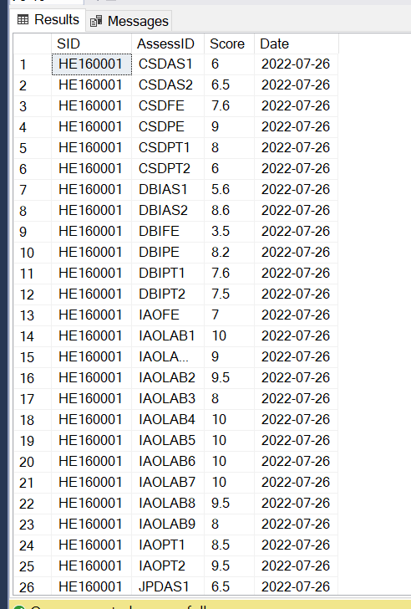

* **SELECT * FROM [View]**

INSERT [View]([Sid], [ClassID], [Average], [Status]) VALUES (N'HE160001', N'SP22IAO1', 7.56555555555, N' PASSED');

INSERT [View]([Sid], [ClassID], [Average], [Status]) VALUES (N'HE160002', N'FA21DBI1', 2.789099999999999, N'NOT PASSED');

INSERT [View]([Sid], [ClassID], [Average], [Status]) VALUES (N'HE160003', N'SP22IAO3', 4.68909999999, N'NOT PASSED');

INSERT [View]([Sid], [ClassID], [Average], [Status]) VALUES (N'HE160004', N'SU21CSD1', 8.76305555555, N' PASSED');

INSERT [View]([Sid], [ClassID], [Average], [Status]) VALUES (N'HE160005', N'SP22CSD2', 6.3440333333, N' PASSED');

INSERT [View]([Sid], [ClassID], [Average], [Status]) VALUES (N'HE160006', N'FA21CSD3', 3.7890996666, N'NOT PASSED');

INSERT [View]([Sid], [ClassID], [Average], [Status]) VALUES (N'HE160007', N'SP22LAB2', 753, N'PASSED');

INSERT [View]([Sid], [ClassID], [Average], [Status]) VALUES (N'HE160008', N'SU21LAB1', 749, N'NOT PASSED');

INSERT [View]([Sid], [ClassID], [Average], [Status]) VALUES (N'HE160009', N'FA21DBI3', 6.7444444444444, N' PASSED');

INSERT [View]([Sid], [ClassID], [Average], [Status]) VALUES (N'HE160010', N'SU21JPD2', 5.222222222222, N'PASSED');

* **Image result**

